Digital Technologies
TE KURA
DTO2202 CHECKLIST WORKBOOK

Name: Levi Poulton | Student Number: 150732911
Digital Technology Teacher: Amanda OConnell

Section 1: Purpose and End users
Refer to Lesson 1 of Module DTO2202

 | Assessment Criteria
Achievement/Paetae | Merit/Kaiaka | Excellence/Kairangi
Describe the purpose of the outcome and the requirements of the end users

Describe the purpose of your intended design:
The purpose of my intended design is to provide (via a website) an easy, holistic, and comprehensive explanation of the Prisoner’s Dilemma with interactive games so that users can learn theory while gaining a practical understanding of (and experience with) the Prisoner’s Dilemma.

The Prisoner’s Dilemma is a classic paradox in Game Theory where acting in your own self-interests may result in an outcome worse for everyone involved (including yourself). In the classic version of a Repeated Prisoner’s Dilemma there are 2 players who have 2 possible actions, to cooperate or defect. If both players cooperate, they are both given 3 points, if one player defects and the other cooperates the defector is given 5 and the cooperator 0, if both players defect no one is awarded points. By playing many consecutive games at a time and then taking the total score of both players, you can decide who “won”.

Most websites and online sources for the Prisoner’s Dilemma do not provide easy interactive learning with comprehensive theory, either focusing on the theory and ignoring practical interactive learning or just have interactive games with little to no theory explained. This can make it hard for someone who wants to learn about the Prisoner’s Dilemma as they would generally have to use multiple sources if they wanted an advanced, holistic, comprehensive grasp of the Prisoner’s Dilemma.

Describe the requirements of the end users:
The users require a website easy to navigate and use. The website should have information in English which can be understood by students, regardless of the experience they have with Game Theory, comprehensive examples and intuitive interactive games which reinforce the explained theory.

Who are your end users? (Describe them – not an introduction, just a description)
The end users are English speaking high school and college students who want to learn about Game Theory, specifically through the Prisoner’s Dilemma, and who may have no prior knowledge of the Prisoner’s Dilemma or who may already know a lot about it.

CHECKPOINT ONE - Upload to the Dropbox
Section 2: Relevant Implications
Refer to Lesson 2 of Module DTO2202

You must select a minimum of 2. (You can come back to this section once you have chosen your final design)

 | Assessment Criteria
Achievement/Paetae  Explain the relevant implications | Merit/Kaiaka,  Address relevant implications | Excellence/Kairangi  Justify how the chosen design addresses implications

Relevant Implication 1
Relevant Implication Name | Accessibility
Explain the implication
(Why have you chosen this implication? What will you do to ensure this implication is addressed in your chosen design?)
I have chosen accessibility as one of the relevant implications so that the website can be accessed easily by anyone, from any device and on any platform. To ensure this implication is addressed, I will design the website so it can be viewed on devices such as phones, laptops, and other screens, on a variety of browsers. For the visually impaired I will ensure the website can be read by screen readers and for colour blind users I will use suitable colour combinations.
Address the implication (answer this once you have selected your chosen design)
(How is this implication addressed in your outcome?)
My website will be coded to be responsive and will automatically resize to a single column website on phones and smaller devices, it will also be made such that it works in Google Chrome, Microsoft Edge and others. The website uses colours that are colour blind safe so that colour-blind users can use it and the website will be coded with alt text for images and overall made to support screen readers.
Justify the implication (answer this once you have selected your chosen design)
(What reasons can you provide to prove that this implication has been addressed in your chosen design?)
My design is accessible for colour-blind users because I used Adobe Colour Blindness Simulator to ensure all my colours are colour blind safe.
Alternatively, if I had just used colours at random without testing their safety, my colour schemes could make the website significantly harder, and maybe even impossible, for colour-blind users, which is estimated to be 4.25% of the global population, to use.

Relevant Implication 2
Relevant Implication Name | Functionality
Explain the implication
(Why have you chosen this implication? What will you do to ensure this implication is addressed in your chosen design?)
I have chosen functionality as one of the relevant implications so that the website can be easily navigated and used in the way the end-user expects. To ensure this implication is addressed, I will design the website so that it meets the needs of the users and achieves its purpose. I will make sure the quality of images used is suitable for the outcome and that the content displays how it should.
Address the implication (answer this once you have selected your chosen design)
(How is this implication addressed in your outcome?)
My website is easy to navigate and button usage is self-explanatory. All content will correctly display in a 2-column structure (for larger devices) or a 1-column structure (for smaller devices). When producing the website, I will make all of the text and infographics relevant to the specific topic of the Prisoner’s Dilemma or references to the broader theme of Game Theory.
Justify the implication (answer this once you have selected your chosen design)
(What reasons can you provide to prove that this implication has been addressed in your chosen design?)
By following conventions, I made the website easy to navigate because users can confidently navigate through it the exact same way they would any other conventional website, by clicking links or their corresponding icons on the navigation bar at the top of the page. By making the buttons stand out and by having a consistent button design users can immediately tell that some action will be taken when they’re clicked and because of the contrast will feel called to action.
Without the implementation of conventions users would be slowed down as they struggled through a new learning process just to be able to use the website, which would make the website less functional. If the buttons were not obvious than users may not realise the actions that will be made when buttons are clicked. This could nullify major features of the website, causing it to not achieve its function as users ignore or misunderstand the usage of buttons. If the content of the website was not to do with the topics the users would expect than the website would not function to serve its purpose as it would not inform them about the Prisoner’s Dilemma.

Relevant Implication 3
Relevant Implication Name | End-user Considerations
Explain the implication
(Why have you chosen this implication? What will you do to ensure this implication is addressed in your chosen design?)
I have chosen end-user considerations as one of the relevant implications so that the website will meet the needs of the end users, the website needing to be easy and intuitive to navigate and use and needing to be informative about the Prisoner’s Dilemma. To ensure this implication is addressed I will design the website with the way the end-user will interact with my outcome in mind and will account for Jakob’s Law, which is that users spend most of their time on other sites, by making the website follow the standard conventions of UX design. I will also make sure the content of the website is relevant, and that the outcome is easily readable, with correct spelling and grammar.
Address the implication (answer this once you have selected your chosen design)
(How is this implication addressed in your outcome?)
My website follows the standard conventions of UX design in the navigation and button design, content hierarchy and colour scheme to make the website easy and intuitive to navigate and use. The text of the website is easily readable and when producing it I will ensure the correct grammar and spelling is used across all of the content so that users can be easily informed of the Prisoner’s Dilemma.
Justify the implication (answer this once you have selected your chosen design)
(What reasons can you provide to prove that this implication has been addressed in your chosen design?)
By following conventions in the design of my website, I fulfil Jakob’s law of “users spend most of their time on other sites”, making it easy and intuitive to use and navigate because everything is loosely the same on my website as every other conventional website. The colour scheme of the website was designed to support colour-blind users which meant all of the colours have good contrast which will make the website even more considerate for even non-colour-blind users because everything is easy to see, especially text.
If my website had not been designed with consideration for end users in the conventions followed than there would be a learning curve for users who just want an easy solution to their problem, which would cause them to likely switch to other, better and more conventional sources. Without the high contrast colour scheme, text would become much harder for all users to read which would make the website not meet their needs as they can no longer get the information they desire. Without correct grammar and spelling users would have to struggle through understanding what they are reading before they can even attempt to understand the meaning of what they are reading, which would not consider their needs.

CHECKPOINT TWO - Upload to the Dropbox

Section 3: Conventions
Refer to Lesson 3 of Module DTO2202

Investigate and apply relevant conventions
Research the conventions that are relevant to your outcome. Try to find at least 4.
List them here and describe what they are. You might not apply them all to the development of your design, but you must apply at least 2

 | Assessment Criteria
Achievement/Paetae  Investigate and apply relevant conventions. | Merit/Kaiaka,  Explain how the chosen design uses appropriate conventions. | Excellence/Kairangi  Justify how the design uses appropriate conventions.

Investigate relevant conventions and describe them. (Once you have chosen your design, come back to this section and, explain and justify how you applied the relevant conventions).
Convention 1: Main Navigation
Describe the convention. | Explain how the chosen design uses the convention. | Justify how the chosen design uses the convention.
The main navigation convention is to have an area at the top of the page with a logo which leads back to the homepage on the left side, and the main navigation elements on the right side. | By applying the main navigation convention as detailed in the first tab my design is easier for the end users to navigate because the navigation system and appearance are familiar. | If my design didn’t follow the convention for navigation, it would lose its use case for majority of the end users because they may not be able to find what they are looking for, at least not easily. Because all of the main information is on pages that aren’t the home page it’s important that users can navigate to those other pages. To ensure this the design needed to follow the convention for navigation bars so that the users wouldn’t get confused, stranded or lost, which they may in a drastically unconventional design. Following this convention has made navigation effortless and predictable for users.
Convention 2: Content Hierarchy
Describe the convention. | Explain how the chosen design uses the convention. | Justify how the chosen design uses the convention.
Content Hierarchy is the idea of splitting content up, mostly into headings, sub-headings and paragraphs, based on their importance and role, and positioning them to guide the user through the information. | By applying the content hierarchy convention as detailed in the first tab my design is easier for the end users to use because if allows them to sift through and process the information systematically. | If my design didn’t follow the convention for content hierarchy, it would become harder and less practical for users to use as it would be harder to gather information from. Because the main purpose of this design is informing users about the Prisoner’s Dilemma it’s important that the information is conveyed clearly. To ensure this design fulfils that requirement it needs to follow the convention of content hierarchy so that users won’t have to struggle through processing the large information. Following this convention means users can easily navigate through and understand the content.
Convention 3: Grid structure
Describe the convention. | Explain how the chosen design uses the convention. | Justify how the chosen design uses the convention.
1 conventional approach to website layouts is a grid structure. This is when objects are positioned around a grid template/guideline. This gives the website a consistent and uniform appearance. | By applying the grid structure convention as detailed in the first tab my design is easier for the end users to use because all of the content is laid out in a standard, orderly and predictable pattern. | If my design didn’t follow the convention for grid structures, it would become more chaotic and disharmonious, making the website harder to use. Because the main purpose of this design is informing users about the Prisoner’s Dilemma it’s important that the users’ attention does not get stolen from the content. To ensure this the design needs to follow the convention of grid structure so that users won’t be distracted by the random chaotic placement of everything, which would significantly slow down and harm the users’ experiences. Following this convention means users can predict where the content is with high accuracy because they know everything will be roughly aligned, which will allow for easier navigation and usage.
Convention 4: Colours
Describe the convention. | Explain how the chosen design uses the convention. | Justify how the chosen design uses the convention.
The general convention with colour usage on websites is to use 2-3 colours and 1-3 neutrals, using tints and shades of the colours if more are needed. This both assists the visual hierarchy and builds brand recognition. | By applying the colour scheme convention as detailed in the first tab my design is easier for the end users to use because it assists the content hierarchy, making content more orderly, and allows for easier identification between similar elements. | If my design didn’t follow the colour scheme convention, it would become more chaotic and harder to navigate and use. Because the main purpose of this design is informing users about the Prisoner’s Dilemma it’s important that the users’ attention does not get stolen from the content. To ensure this the design needs to follow the convention of colour schemes so that users won’t be distracted by the random chaotic colours which would hinder consumption of the information. Because the website holds a relatively large amount of content, element recognition is very important as it allows for easier experience, particularly with interactive parts. To allow for this, similar elements have similar or the same colours, allowing users to easily recognise that a new element will function in the same way as an old element did, instead of forcing them to relearn its functionality. Following this convention has meant that users can predict the functionality and roles of items in the content and process information easier without distractions.

CHECKPOINT THREE - Upload to the Dropbox

Section 4: Research, Modelling and Improving
Refer to Lesson 4 and 5 of Module DTO2202

In this section, keep in mind the purpose, end-users, relevant implications and conventions as you research to find outcomes that you can use to help inform your decisions around the development of your design.
Check in to the Module about what to research and how to document your findings. (A PMI chart is an option). Model your designs (mock-up) and gather feedback to refine your designs until you can decide on the best design.

 | Assessment Criteria
Achievement/Paetae  Generate and model a range of design ideas | Merit/Kaiaka,  Use feedback gained from modelling to improve the design | Excellence/Kairangi  Develop a refined design
Section 4: Research
Refer to Lesson 4 of Module DTO2202

Complete research around design elements:
(For example, colour, composition, fonts, best graphic design practice. Refer to lesson 3 of the online module - Click here)
Colour Associations:

Black:
- A simple shade which can be very powerful
- Represents luxury, elegance and formality
- Associated with class, sophistication and timelessness
- Can be associated with coldness, evil or death
- A good accent colour or colour for text

White:
- A simple colour which can be very powerful
- Subtly represents simplicity and elegance
- Associated with modern, sleek and cleanliness
- Can be associated with calmness, relaxation or neutrality
- If used poorly, can seem lazy, plain or lacking
- Stands out in a peaceful way making it good for text
- The favourite colour of a small portion of men and women

Blue:
- A calming primary colour with some strong effects
- Represents relaxation, serenity and trust
- Associated with wisdom, strength and trust
- Can be associated with unity or connections
- Can be associated with coldness or lack of emotion
- Favourite colour of majority of men and of a third of women

Red:
- A powerful primary colour which can spark strong emotions
- Represents leadership, urgency and excitement
- Associated with power and passion
- Can be associated with anger or danger
- The favourite colour of about 7% of men and 9% women

Yellow:
- A bright primary colour with strong effects
- Represents optimism, intellect and positivity
- Associated with happiness, sunshine and fun
- Can be associated with cheapness, fear or anxiety
- The favourite colour of a small portion of men and women

Green:
- A relaxing secondary colour which is easy on the eyes
- Represents peacefulness and quality
- Associated with nature which gets associated with growth, health and freshness
- Can be associated with money
- Can be associated with boredom
- Favourite colour of about 1 in every 7 people (14% of both men and women)

Purple:
- A soothing secondary colour which is good for portraying imaginative culture
- Represents luxury, creativeness and regal
- Associated with mysteriousness or new ideas
- Can be associated with bits from red and blue, such as trust and stimulation
- Can be associated with moodiness
- Favourite colour of about a quarter of women but almost no men

Orange:
- A friendly secondary colour which gives a strong feeling of warmth
- Represents haste or movement
- Strongly associated with Autumn and the sun
- A “friendlier” red
- Can be associated with frustration and immaturity
- The favourite colour of about 5% of men and women

Generalisations:
- Cool colours have a calming impact, a relaxed, serene or trusting effect
- Warm colours create boldness and excitement

Fonts:

Hierarchy:
- The order in which you read your information based on typeface, scale, position and style

Alignment:
- The arrangement or adjustment of components to make them sit together

Serif:
- Has small projections at the end of letter strokes
- More formal and traditional
- E.g. Times New Roman

Sans Serif:
- Has no stoke embellishments or details
- More modern and bold
- E.g. Arial

Script:
- Linked letter-to-letter
- Adds elegance or a personal touch
- E.g. Great Vibes

Slab Serif:
- Thick, block like serifs
- E.g. Rockwell

Web Design:

Good Design is Innovative:
- Always try to push the boundaries
- Use creativity to stand out
- Keep up with the newest tools

Good Design Makes a Product Useful:
- Useful for the user – easy to find what they are looking for
- Useful content – without great care with the content your website can lose its usefulness

Good Design is Aesthetic:
- Balance between visual details and usefulness
- Beautiful websites provide a unique experience while presenting relevant content
- Colour, grid structure and typography are important

Good Design Makes a Product Easy to Understand:
- Make it easy for your user to reach their goal

Good Design is Unobtrusive:
- Less is more – user should find the information as fast as possible; use white space
- Accessibility

Good Design is Honest:
- Give the user all the options
- Don’t try to make the product seem more important than it is
- Clearly clarify what options or buttons do
- Show error messages to the user

Good Design is Long Lasting:
- You don’t need to follow every design trend nor redesign everything every time something new comes out

Good Design is Thorough

Other:
- A picture speaks a thousand words
- Use conventions for the user’s easier navigation
- Keep consistent
- Keep a low load time
- Keep accessible for mobile

Bibliography
Colours: https://www.lyfemarketing.com/blog/color-psychology/, https://www.colormatters.com/color-and-design/basic-color-theory, https://www.johnlovett.com/color and https://neilpatel.com/blog/choose-best-color-conversion/
Fonts: https://www.canva.com/learn/the-ultimate-guide-to-font-pairing/, https://vimeo.com/138558809 and https://www.flux-academy.com/blog/the-ultimate-guide-to-choosing-fonts
Web design: https://www.lyfemarketing.com/blog/effective-website-design/ and https://www.creativebloq.com/netmag/dieter-rams-10-principles-good-web-design-3143872

Research designs (at least 3):

Research Design 1
Insert screenshot of design here:
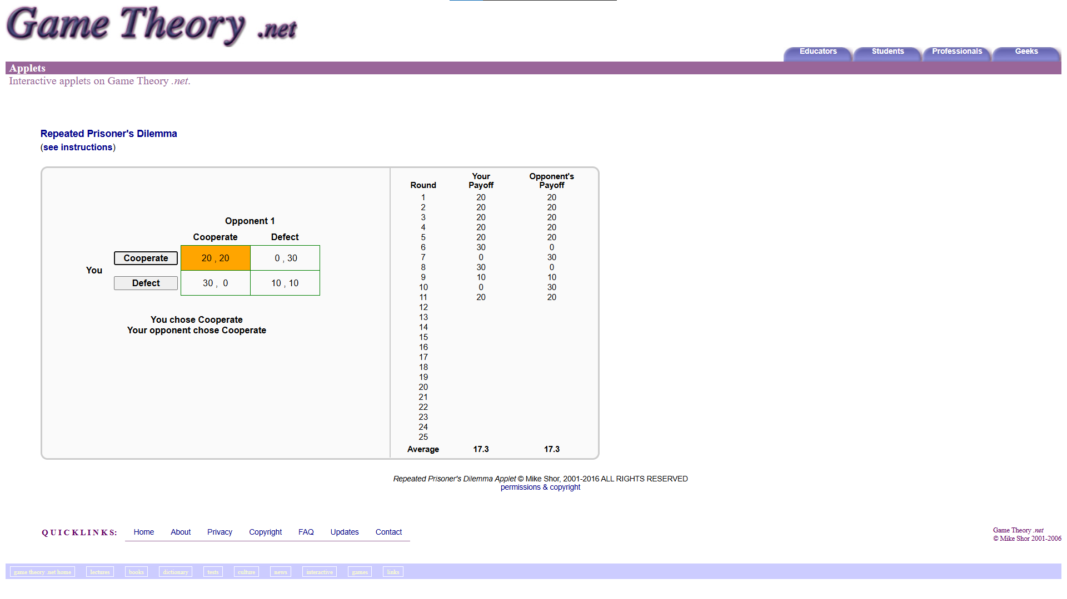
Design 1:  (Include a title and brief description) | Interactive Repeated Prisoner’s Dilemma Page on GameTheory.net – An interactive applet to play a Repeated Prisoner’s Dilemma.
End users: | Students and academics.
Source and creator:  (include the original URL) | https://www.gametheory.net/Mike/applets/PDilemma/Pdilemma.html - Mike Shor
Conventions: | Logo links to home page and is at the top of the page with (some of) the navigation.  Buttons are styled in way such that you know they are buttons.  Main content is at the top of the page (under most of the navigation).  The footer is at the bottom of the page.
Notes/Thoughts/Brainstorm:
(Make comments on design choices that work and that do not work. Consider the plus, minus and interesting. What parts of the design are relevant to your purpose, end users and relevant implications.?
Positives | Negatives | Interesting
The light purple gives a somewhat soothing effect.  Buttons slightly change styles when hovered on.  The link (“see instructions”) is blue and gets underlined when hovered on so you know it’s a link.  The interactive game works and is fairly intuitive. | The large amount of white space looks lazy.  Most of the navigation is located at the bottom of the page, the opposite of convention.  Content in the footer is hard to read due to low contrast between colours and the font as well as the font size.  The link (“see instructions”) is the same colour and font as the title, making it hard to distinguish. | The contrast between the yellow and everything else draws attention to the results of a round.  The minimalistic style makes playing the game really easy.

Unique takeaway: there are limits to how minimalistic something can be before it feels lazy.

Research Design 2
Insert screenshot of design here:
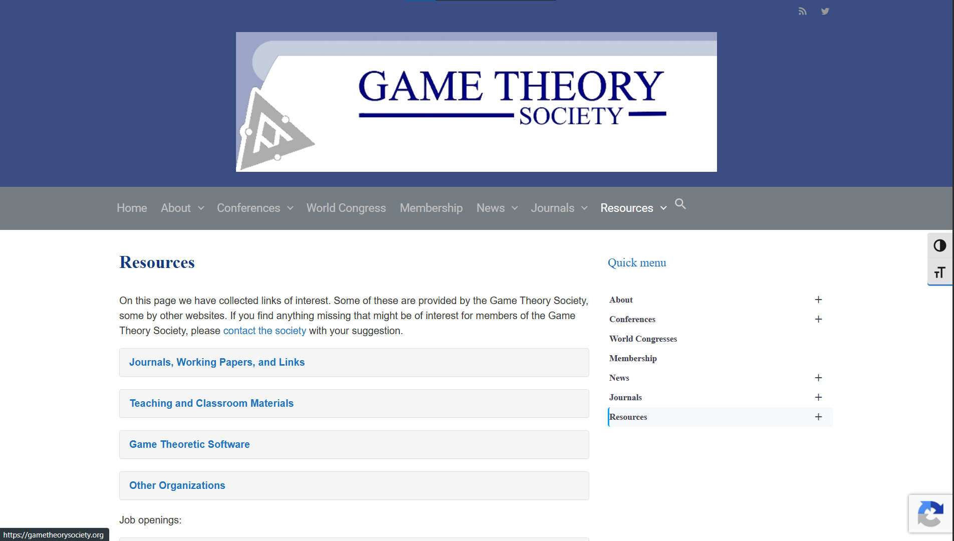
Design 2:  (Include a title and brief description) | Resources Page from Game Theory Society – A link directory to help users find their way around the site.
End users: | Professors, scholars, students, members of the Game Theory Society and interested parties.
Source and creator:  (include the original URL) | https://gametheorysociety.org/resources/ - Game Theory Society, no specific creator given.
Conventions: | Logo is at the top of the page.  Main navigation is below the logo at the top of the page.  Navigation links are categorised and expand on hover.  There is a search bar in the navigation.  Built with a grid-like structure.  Buttons and links are easily recognisable.  Link to their social is in the top right corner.
Notes/Thoughts/Brainstorm:
(Make comments on design choices that work and that do not work. Consider the plus, minus and interesting. What parts of the design are relevant to your purpose, end users and relevant implications.?
Positives | Negatives | Interesting
Uses a consistent colour scheme which builds brand recognition.  The colours used, shades of blue, give a relaxing effect and are associated with wisdom, trust and unity.  The links are a light blue, different enough that they are distinct from the colour of the titles and other content.  Buttons are obvious and their usage intuitive.  Good standard font choices.  Negative space is used well, the white does not feel overwhelming or lazy but intentional and easy on the eyes. | Nothing unique, gives a boring (although professional) feel.  Search icon is not centred in their navigation. | The link to their twitter is a small icon in the top right corner. - During my research I found critique on having large, standout social buttons at the top of the page as they make it easy to distract and take users away from your website.  The logo is quite large and centred above the navigation, drawing users’ eyes to it immediately.  Website doesn’t have a footer, instead when you scroll a button appears which brings you up to the top of the page.

Unique takeaway: keep the design professional but add something to keep the content interesting.

Research Design 3
Insert screenshot of design here:
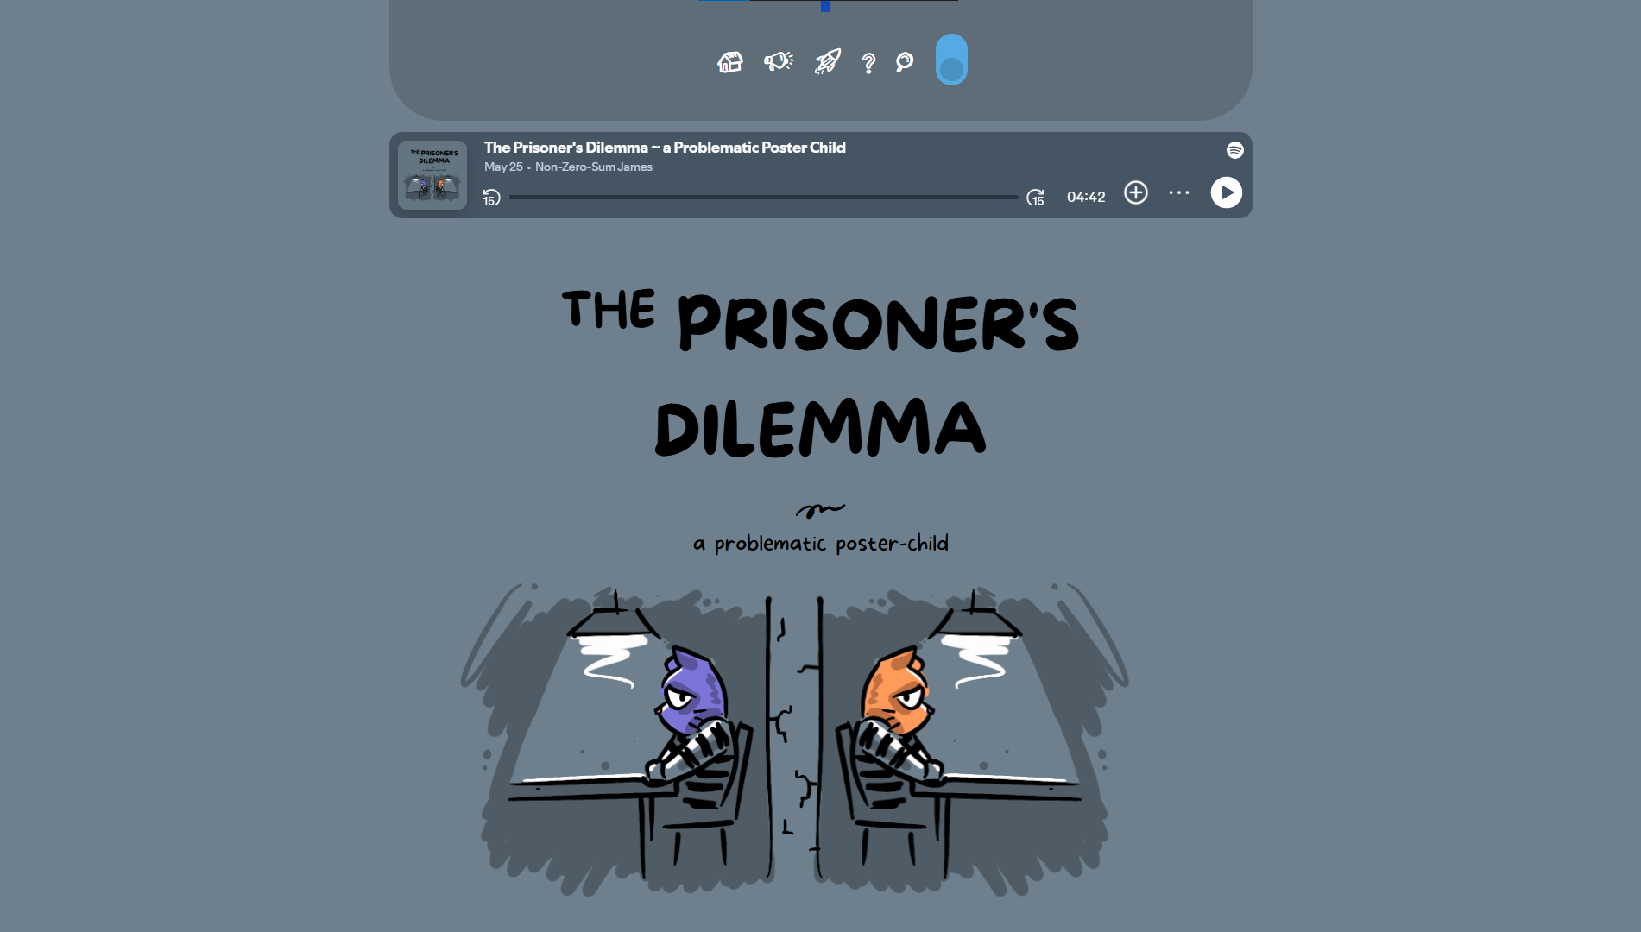
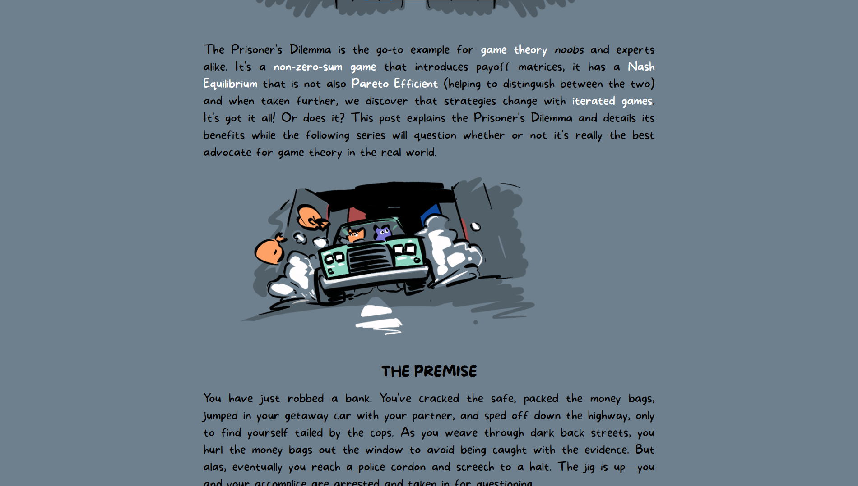
…
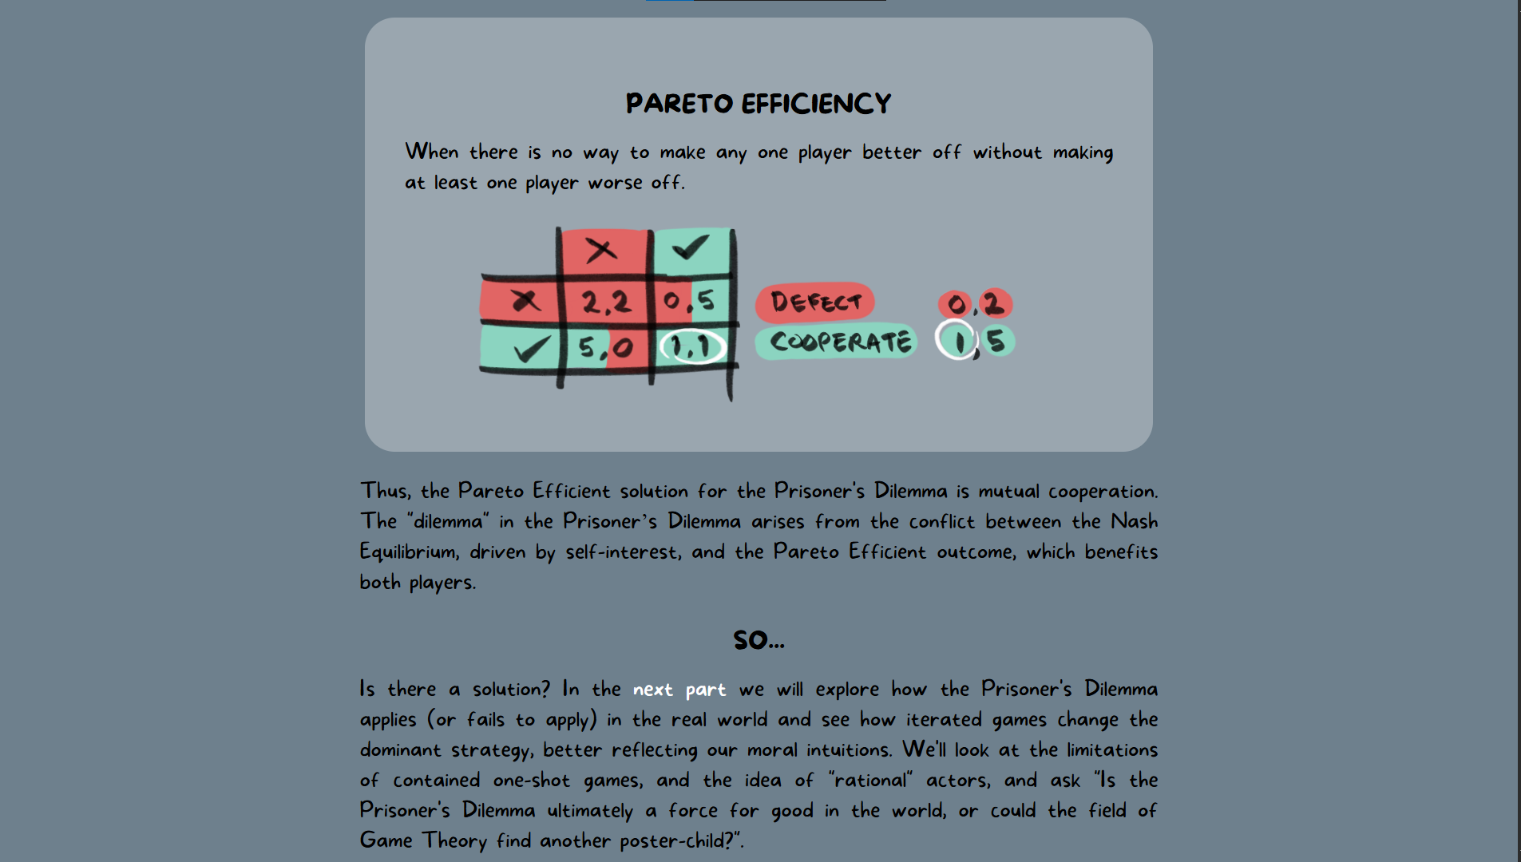
Design 3:  (Include a title and brief description) | A post explaining The Prisoner’s Dilemma from nonzerosum.games – a post explaining how the prisoner’s dilemma works.
End users: | Teachers and children.
Source and creator:  (include the original URL) | https://nonzerosum.games/prisonersdilemma.html - Non-Zero-Sum James (James Stephan Brown)
Conventions: | Navigation is at the top of the page.  There is a search bar accessible from the navigation.  Info graphics are used to explain ideas.  Built with a grid-like structure.  Buttons and links are easily recognisable.
Notes/Thoughts/Brainstorm:
(Make comments on design choices that work and that do not work. Consider the plus, minus and interesting. What parts of the design are relevant to your purpose, end users and relevant implications.?
Positives | Negatives | Interesting
Links are intuitive and stand out.  Infographics and pictures break up the content.  The main colour used, a bluey grey, givers a relaxing effect and is associated with wisdom and trust.  Negative space is used well, the content does not feel empty or squashed. | The font, although fun and suitable for the audience, can be distracting and hard to read.  Because of how long the content is, scrolling back to the top from the bottom is annoying. | Infographics and suitable pictures are used consistently to convey ideas and retain attention.  The audio at the top of the page makes the content more accessible and user friendly.

Unique takeaway: use appropriate (more suitable for an older audience than those used in the above design) infographics and images to help convey points and retain attention.

Feel free to include other design solutions that you have researched.

Section 4: Modelling
Refer to Lesson 5 of Module DTO2202

Create 3 different mockups/sketches of designs.
When creating your mockups/sketches/wireframes, you are welcome to use pencil and paper, MS Word, Google Doc, online tools, or any other design software that is not used to actually create an outcome. These could be shapes with text to explain what it might look like. You cannot use any Generative AI for this as they must be your own authentic work.. The mock-ups are meant to give end users an idea and feel for what the intended design will look like and do. You are not creating final designs at this point. When creating your designs try your best to make 3 very different designs.

You can annotate font choices, colours, layout, size etc in your mock-ups

NOTE: Modelling requires that you start with three different designs. After your first round of feedback, you can narrow down your number of designs to two or one based on the feedback you receive. The purpose of modelling is so that you end up with one final design that can be taken on to further development. ALL FEEDBACK COLLECTED SHOULD INFORM THE DECISIONS YOU MAKE IN YOUR DESIGNS

Design 1
Brief description of your design: Wireframes of a header, footer, example info section and a simple prisoner’s dilemma game interface, with a sidebar for navigation. Uses 2 blues, a cyan, a light green, a grey and black. Follows a 12-column grid pattern.
Screenshot of mockup:
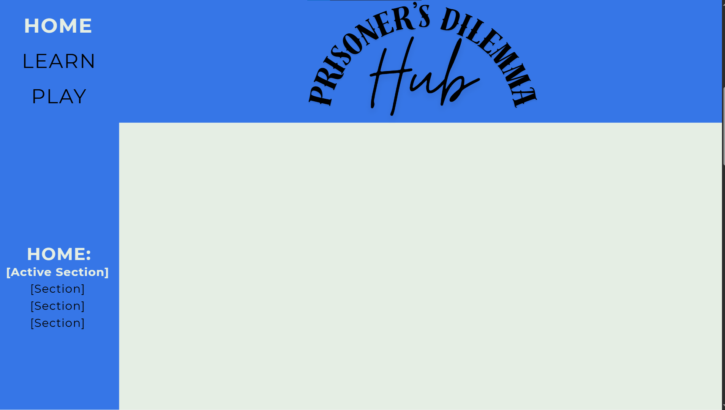
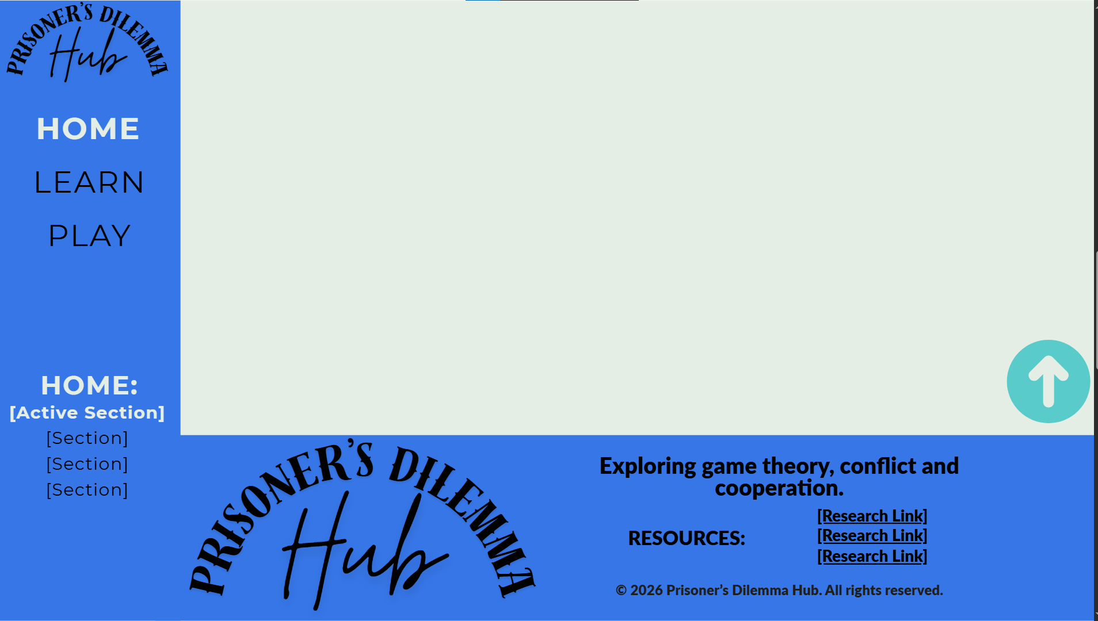
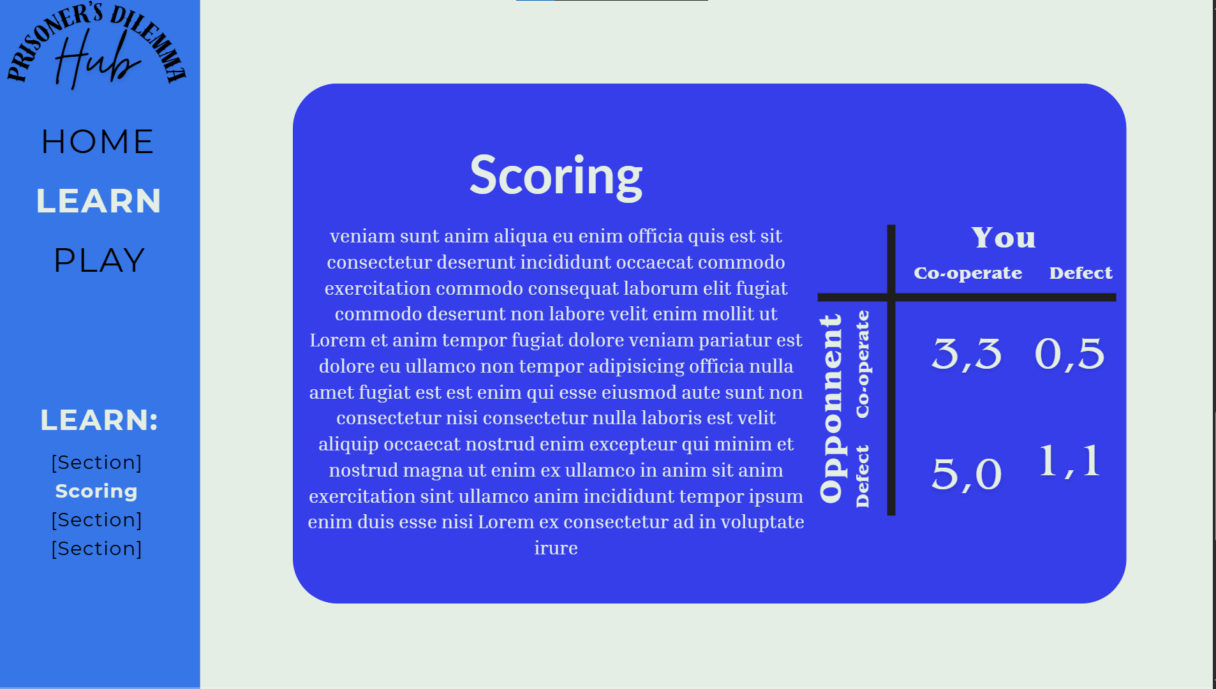
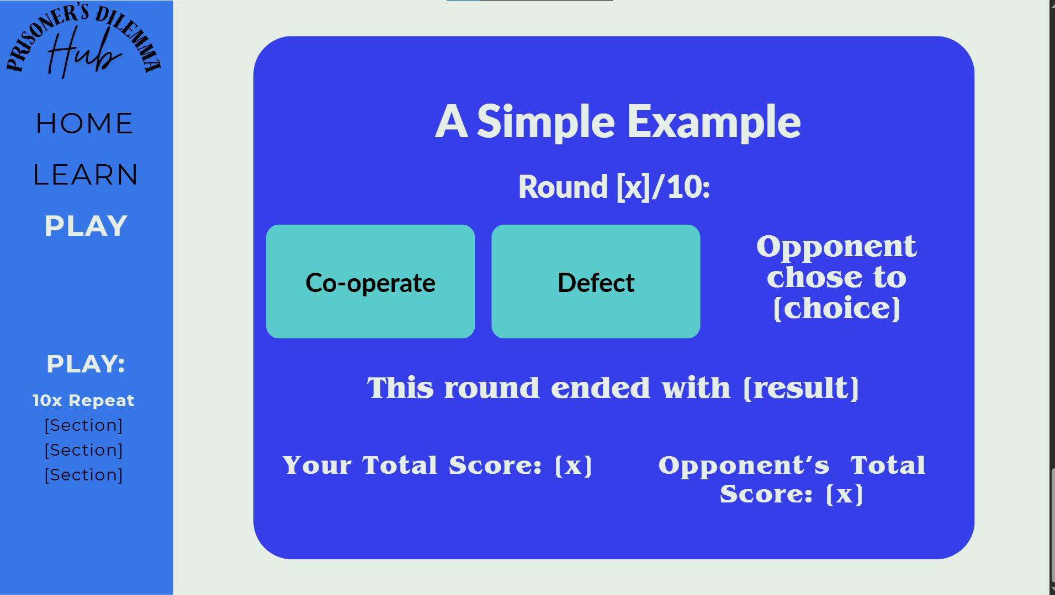
Other relevant design choices:
Please include intended font choice, color scheme, images and any other relevant information linked to your design
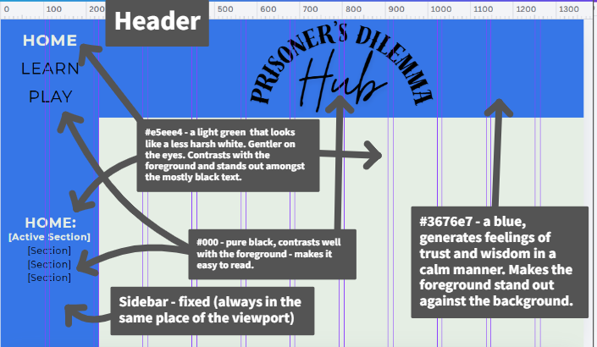

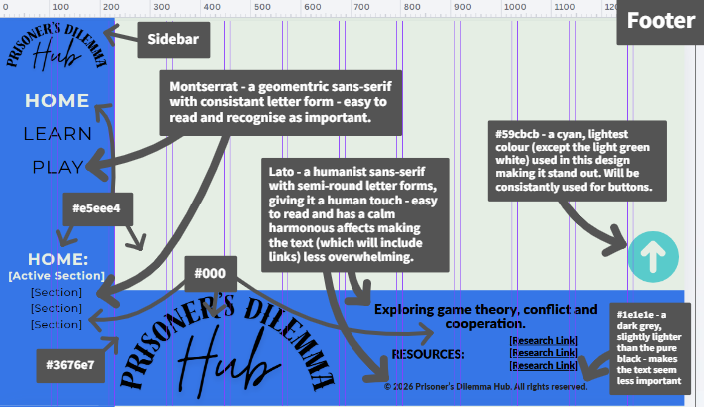
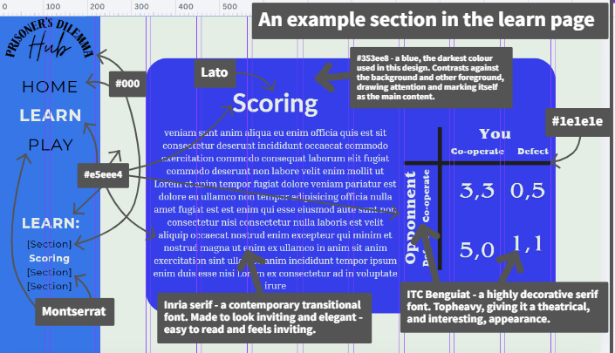
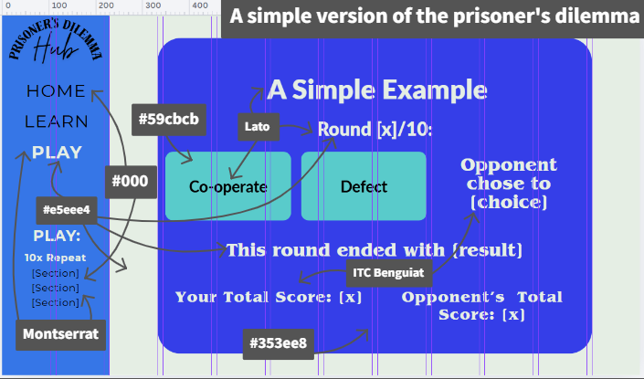
Colours used in this design:
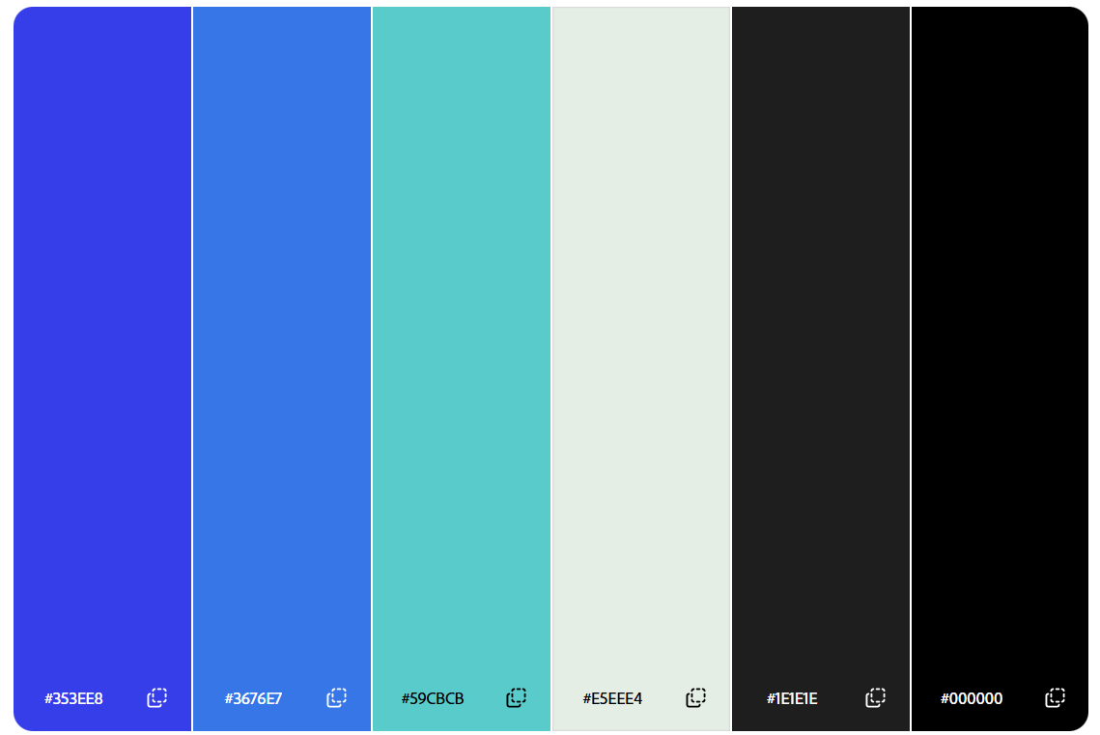
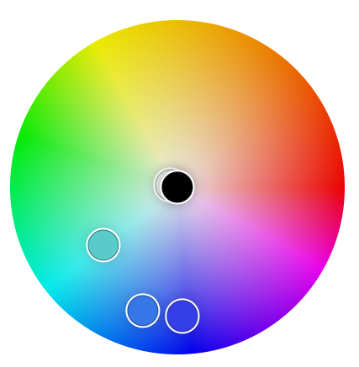

Passes adobe colour blindness simulator:
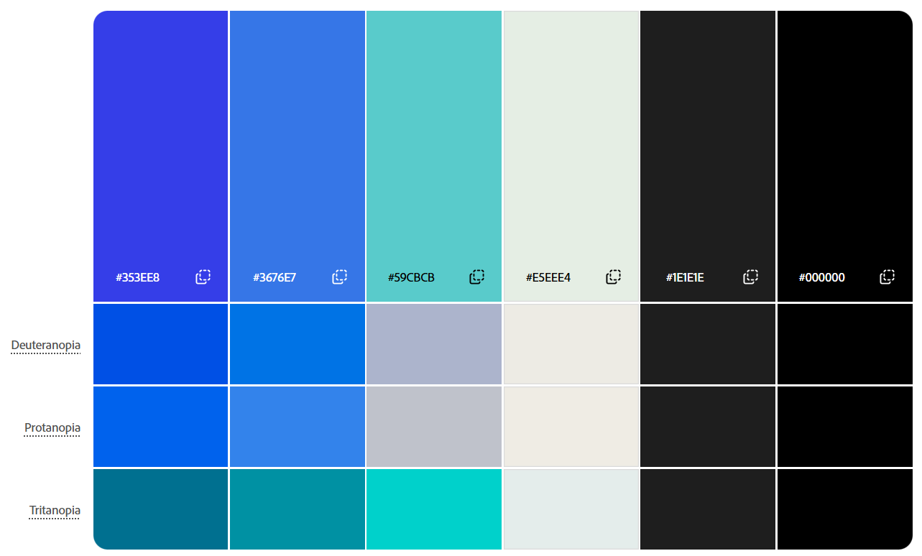

Element size, positioning and spacing was largely based around a 12 column (with gaps) grid – one of the default Canva website design guidelines.
Design 2
Brief description of your design: Wireframes of a header, footer, example info section and a simple prisoner’s dilemma game interface. Uses a pink, purple, green, cyan and black along with particular fonts to create a more elegant feeling. Built around a 12 column (with gaps) grid structure.
Screenshot of mockup:
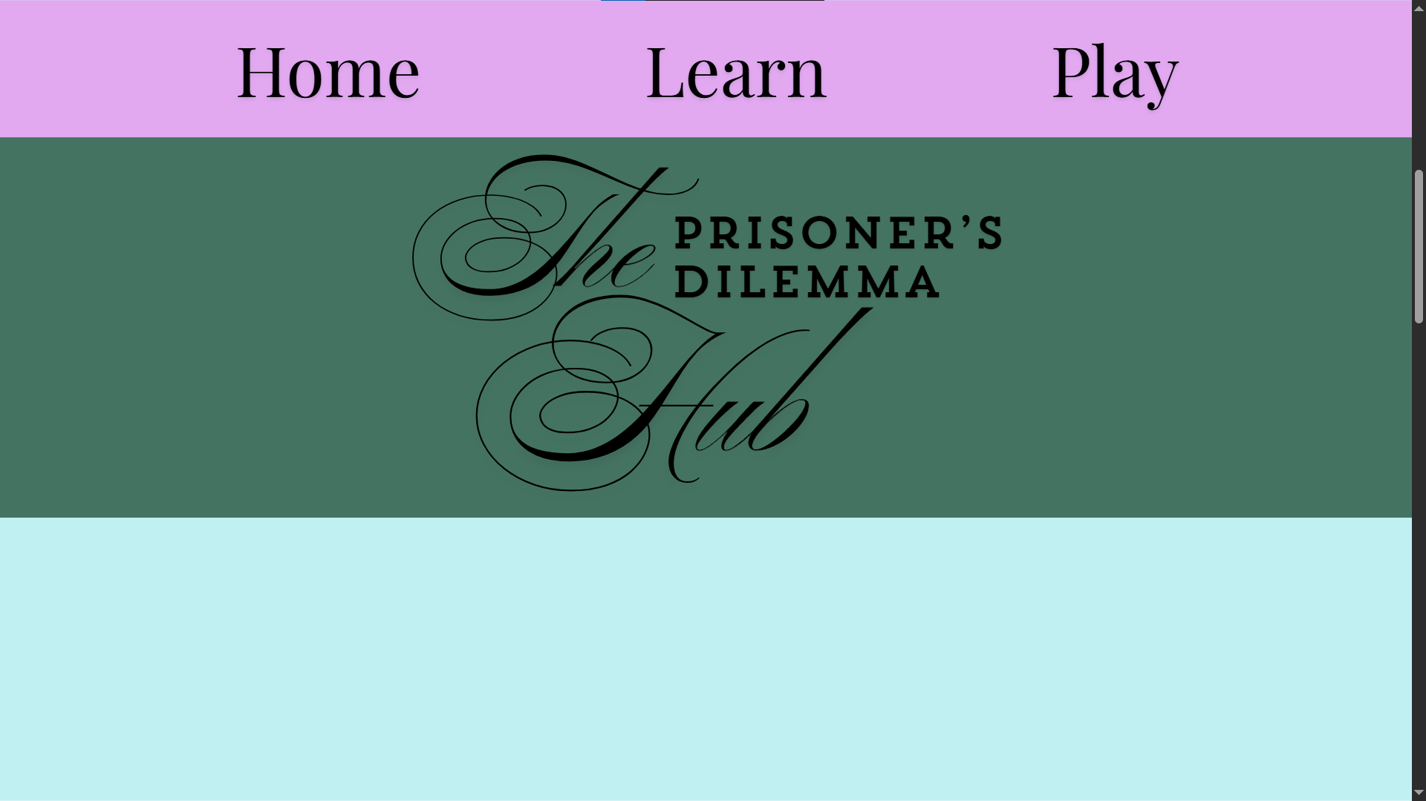
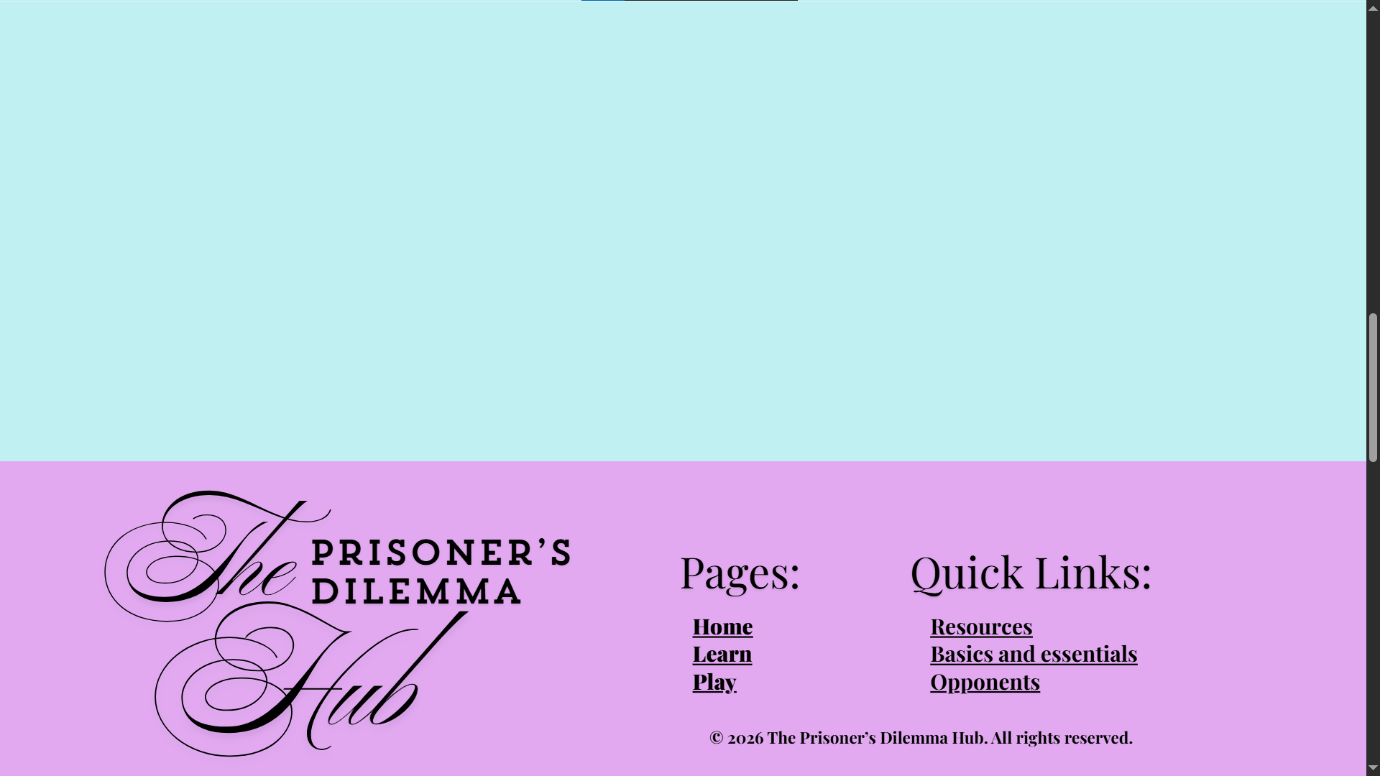
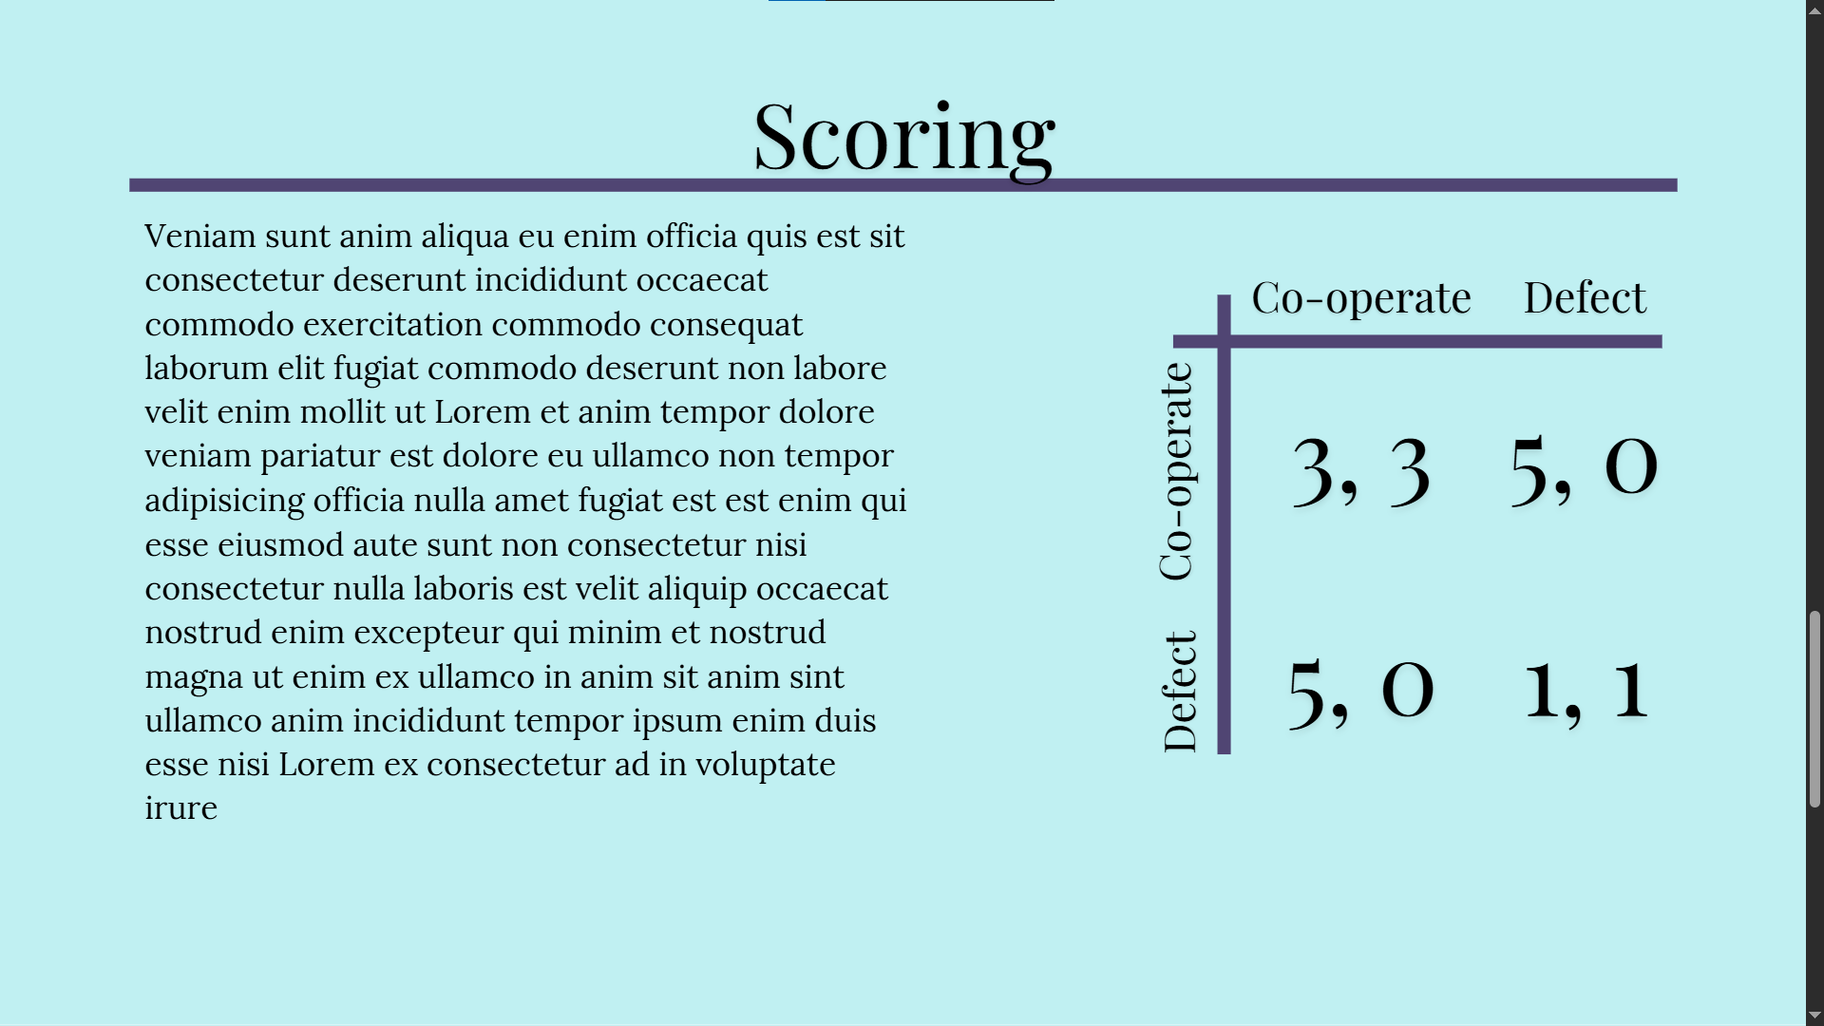
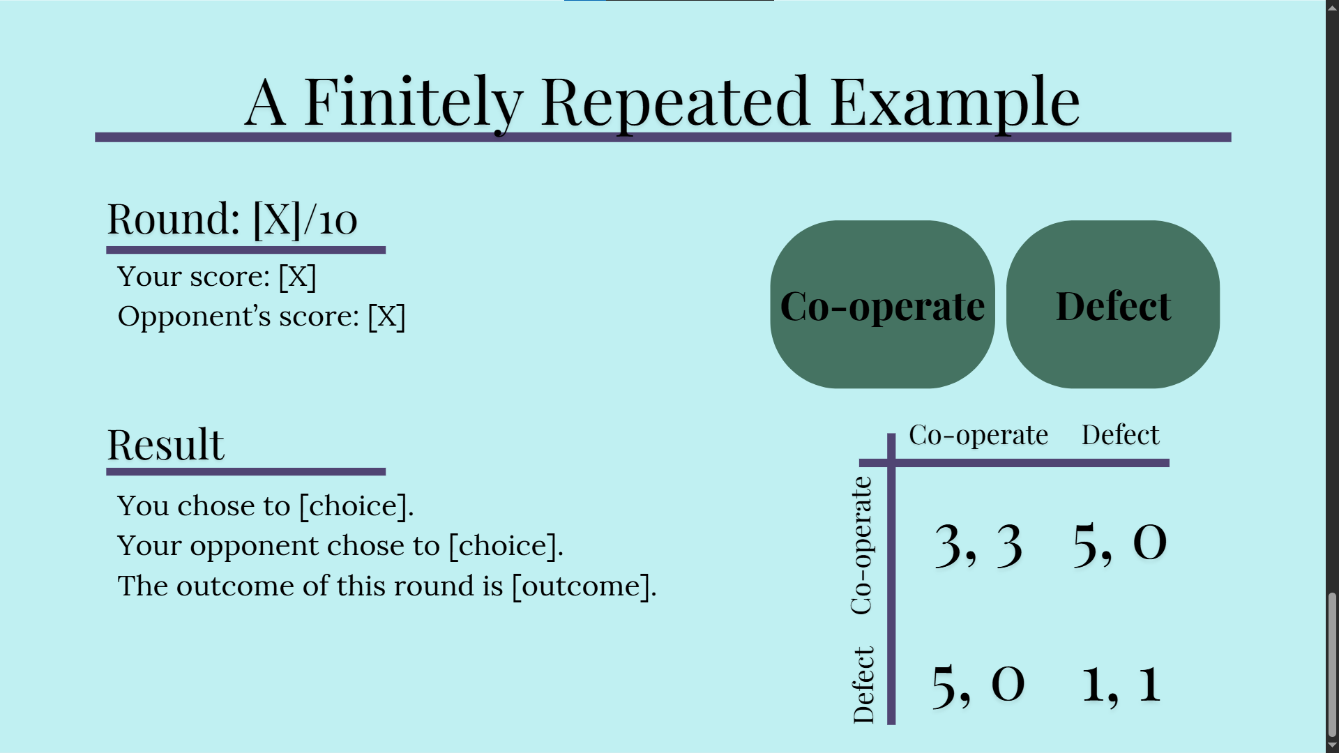
Other relevant design choices:
Please include intended font choice, color scheme, images and any other relevant information linked to your design
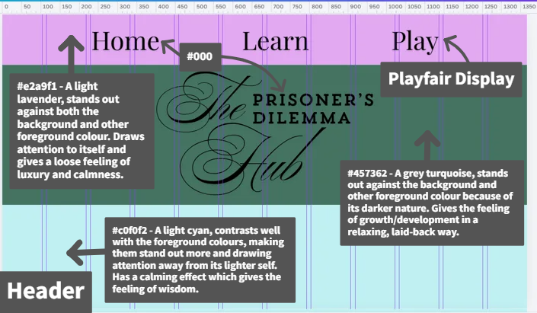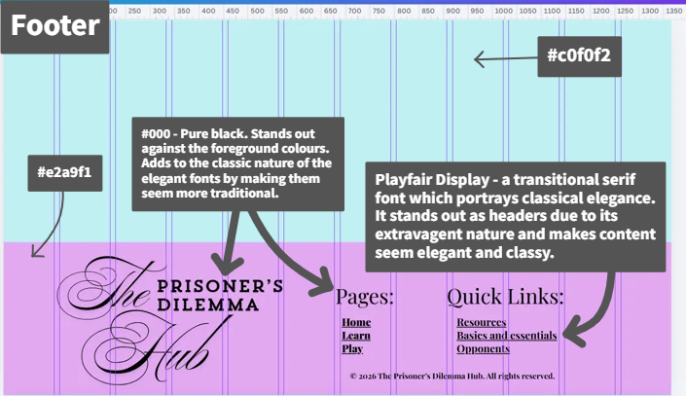
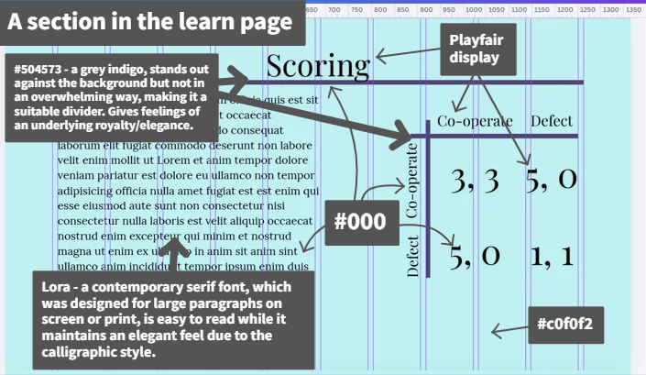
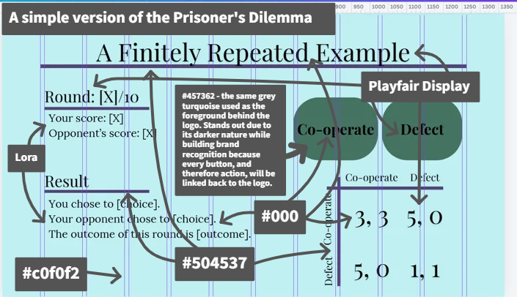
Colours used in this design:
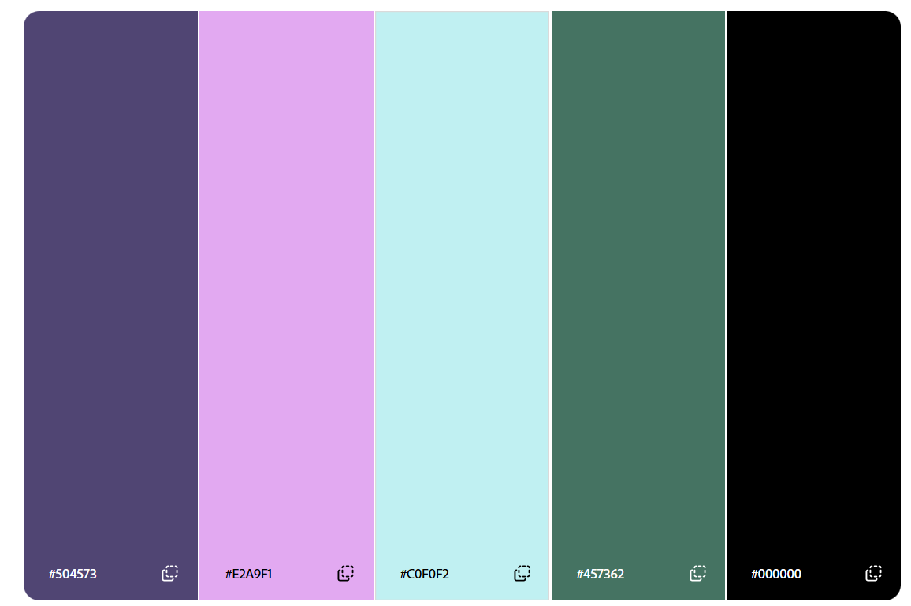
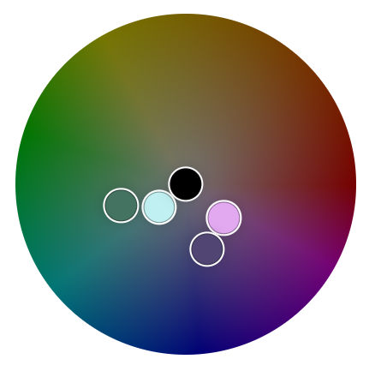

Passes Adobe colour blindness simulator:
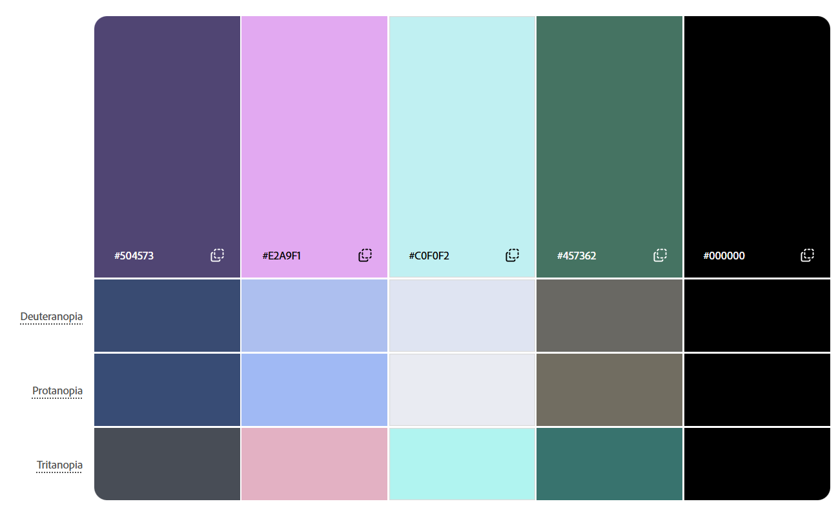

Element size, positioning and spacing was largely based around a 12 column (with gaps) grid – one of the default Canva website design guidelines.

Design 3
Brief description of your design: Wireframes of a header, footer, example info section and a simple prisoner’s dilemma game interface. Uses 2 purples, 2 greys, pure black and pure white and follows a 12-column grid pattern.
Screenshot of mockup:
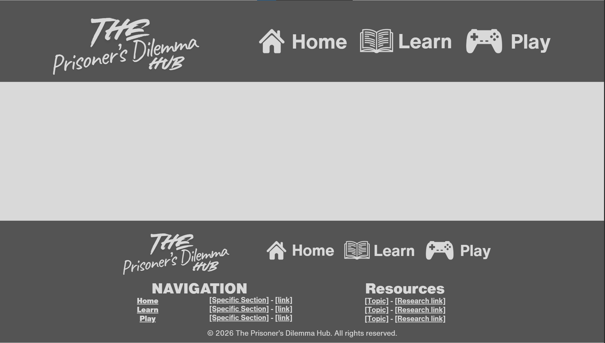
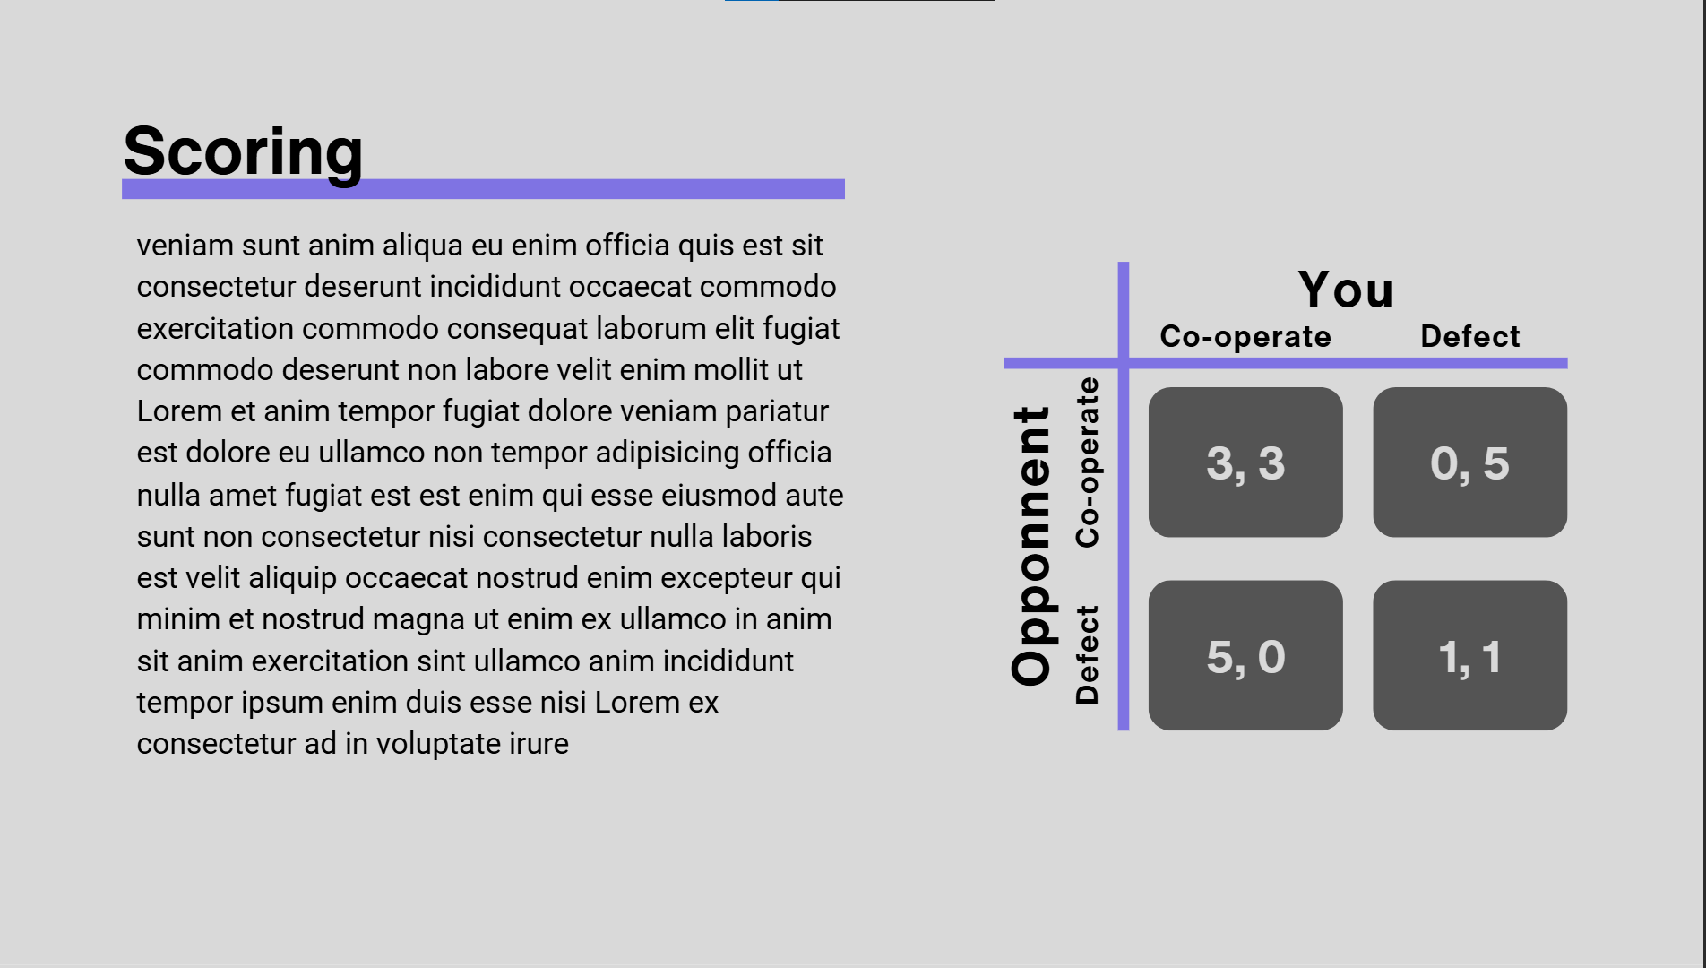
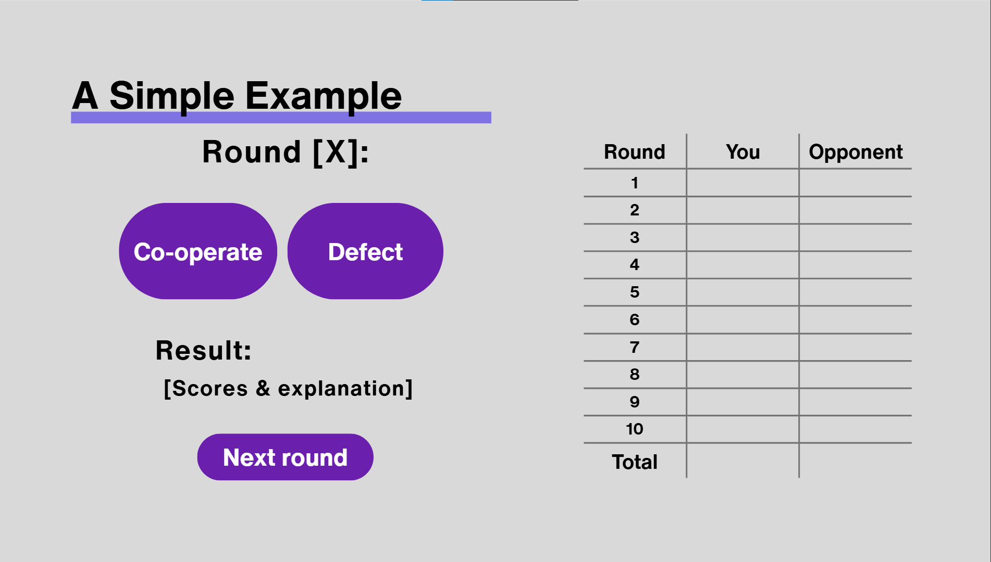
Other relevant design choices:
Please include intended font choice, color scheme, images and any other relevant information linked to your design
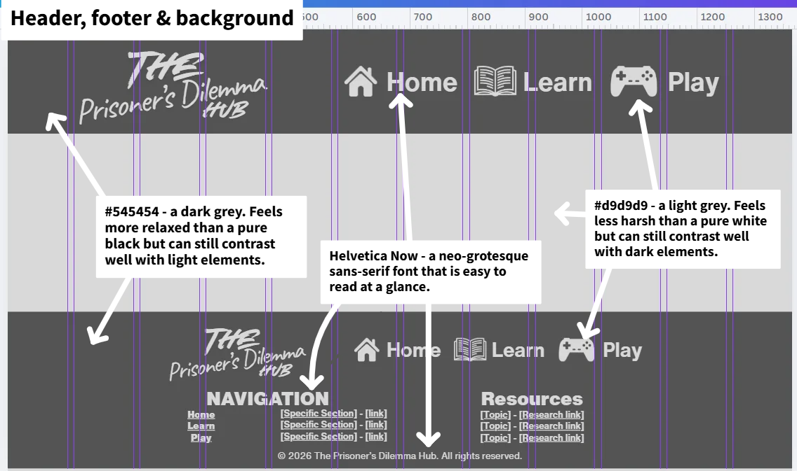
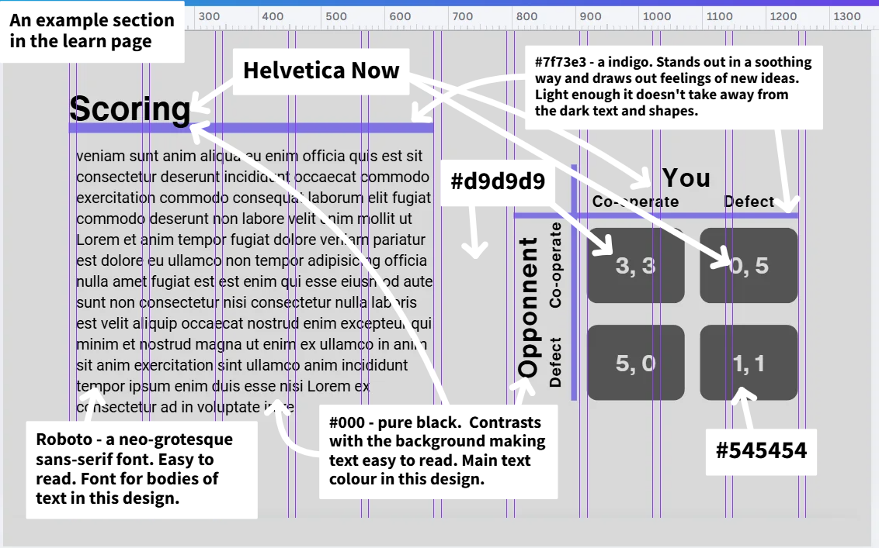
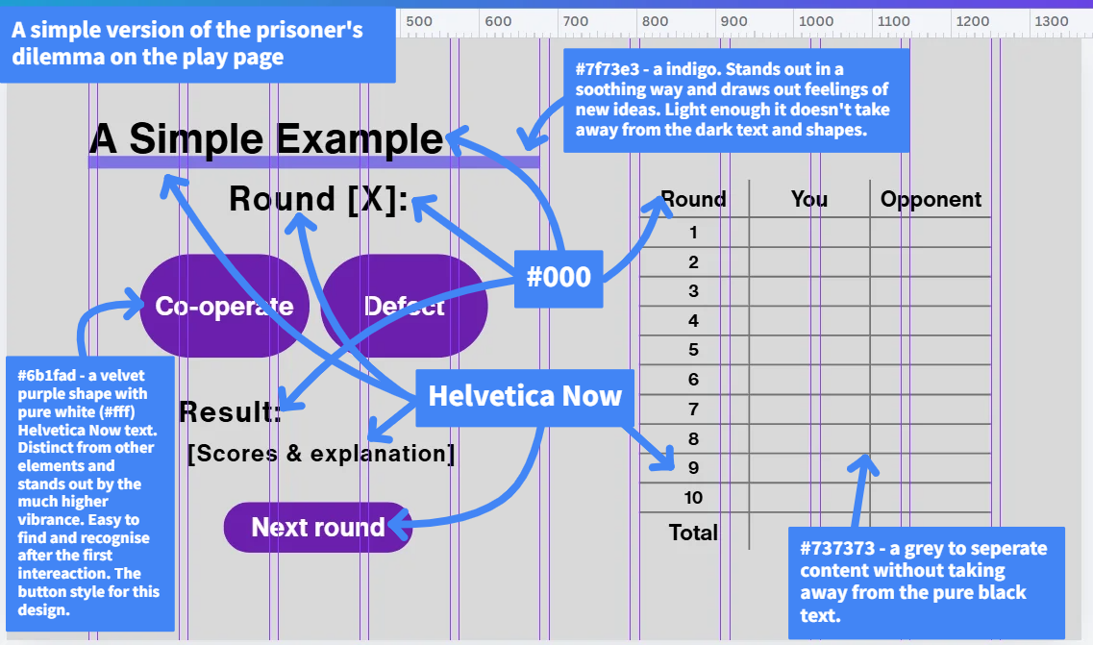

Colours used in this design:
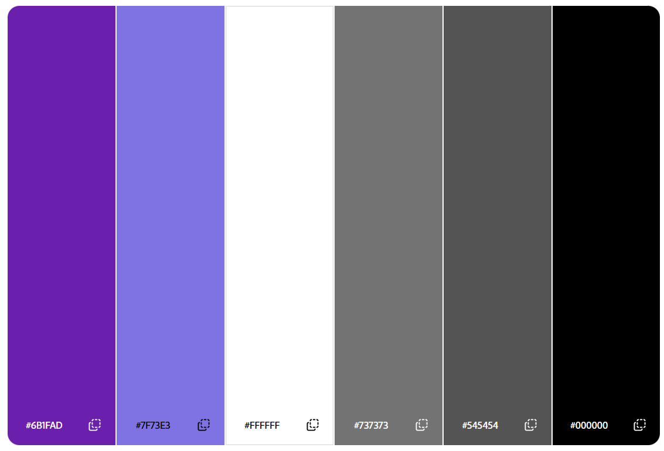
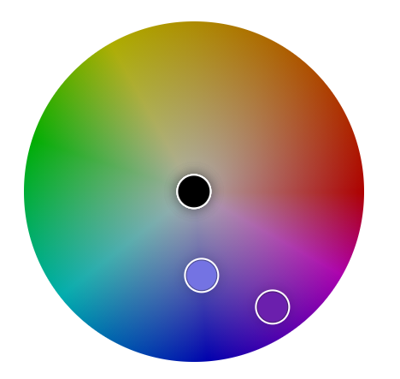

Passes adobe colour blindness simulator:
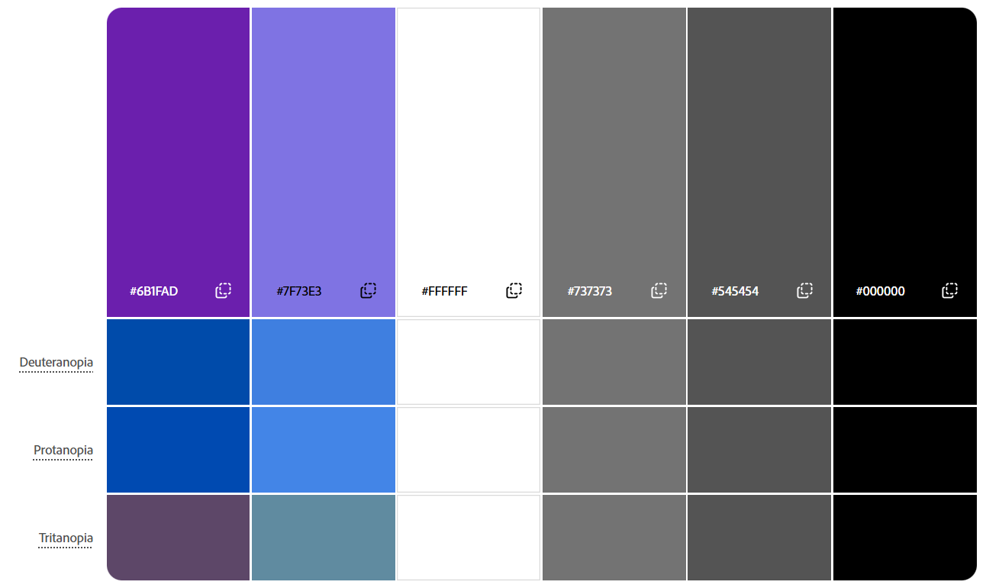

Element size, positioning and spacing was largely based around a 12 column (with gaps) grid – one of the default Canva website design guidelines.

CHECKPOINT FOUR Upload to the Dropbox

Section 4: Improving
Refer to Lesson 5 of Module DTO2202

Seek and gather feedback about the mockup of each of your designs from a variety of end users until you are satisfied that you have met the purpose, needs of end users and relevant implications.

Round 2 and Round 3 might consist of one design only if the first round of feedback returns a clear favourite. Adjust accordingly.

In gathering feedback you may like to use an online platform to gather your feedback for example Google forms.
When asking for feedback make sure your questions link to your purpose, end-users and relevant implications. For example, ask questions to find out if:
- The purpose has been met
- The needs of the end-users have been met
- The design is presented clearly
- The design is culturally appropriate
- The design is suited to the needs of the end user
- The design is aesthetically pleasing
- The design is suitable for the context
- The colours work
- The layout works
- The images are relevant
- The message is clear

EVIDENCE ROUND 1 (You may have only one or two designs to continue with based on feedback from your first round of modelling)
Feedback: Link to feedback if collated in a Google product or other online platform
https://docs.google.com/forms/d/1132RNnebLcJeUs-_cCgJhdybNuTEdAaOx9PL1O10M_4/edit
Name of document feedback is recorded in is:
https://docs.google.com/spreadsheets/d/1yBAAR0faNxjnkDaR4yBWCc1Rb4CAJiTPtaCmkn7wToQ/edit?usp=sharing
FEEDBACK SUMMARY
Design | Likes/Keep | Dislikes/Change | Summary
Design 1 | Colours:  - Button colours  - General blue theme | Colours:  - Main colours were too monotonous  - Font colour wasn’t the same throughout  - The blue in the foreground content boxes  - Button colours  Fonts:  - Logo feels out of place with the rest of the fonts  - Logo emphasises the wrong part of the title  Positioning:  - The box foreground for the content  - Put more emphasis on the infographic  Other:  - Wants bigger text in the buttons  - Change the font of the buttons to stand out more  - Put more emphasis on the buttons  - Add font decorations to navigation links | Least liked design. Colours were monotonous and inconsistent, for the most part didn’t look nice but a couple blues were liked. Fonts were good aside from the logo. Didn’t like the boxes around all the content. Buttons and navigation links needed more emphasis.
Design 2 | Colours:  - Pink, blue, purple & teal  - Easy on the eyes to read text off the teal background  Fonts:  - Everything but logo  Positioning:  - Layout of learn and play pages | Colours:  - Green  - The contrast between green and pink  - Make header a consistent colour  Fonts:  - Use a consistent font in the logo  Positioning:  - Make the buttons more centric | The second most/least liked design. Colours were all nice aside from the green and pink contrast in the header. Didn’t like the inconsistent logo. Overall layout was good but buttons needed more emphasis/clarity.
Design 3 | Colours:  - The purples and grey are nice  Fonts:  - Everything but logo  Positioning:  - Everything  - Particularly button position | Colours:  - Too monotonous – particularly header and footer  Fonts:  - Logo  Positioning:  - Infographic slightly bigger  Other:  - Make the navigation links stand out a little more | The most liked design. Too much grey however the purples looked really good with it, there just wasn’t enough of the colours to contrast with the grey. Didn’t like the inconsistent logo. Positioning was all done well but would prefer a slightly larger infographic. Buttons were done well but wanted slightly more emphasis on the navigation links.

Improved Design 1
Brief description of your design:
Improved design choices:
Please include intended font choice, color scheme, images and any other relevant information linked to your design based on your Feedback

Improved Design 2
Brief description of your design: Wireframes of a header, footer, example info section and a simple prisoner’s dilemma game interface. Uses pink, purple, cyan and black colours along with particular fonts to create an elegant feeling. Built around a 12 column (with gaps) grid structure.
Screenshot of mockup:
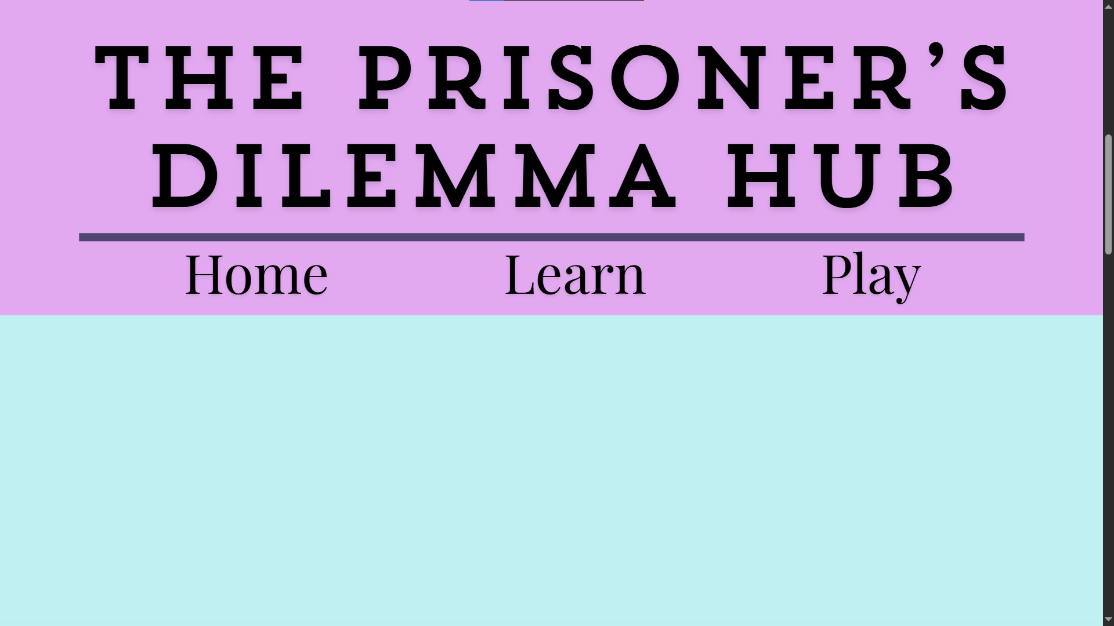
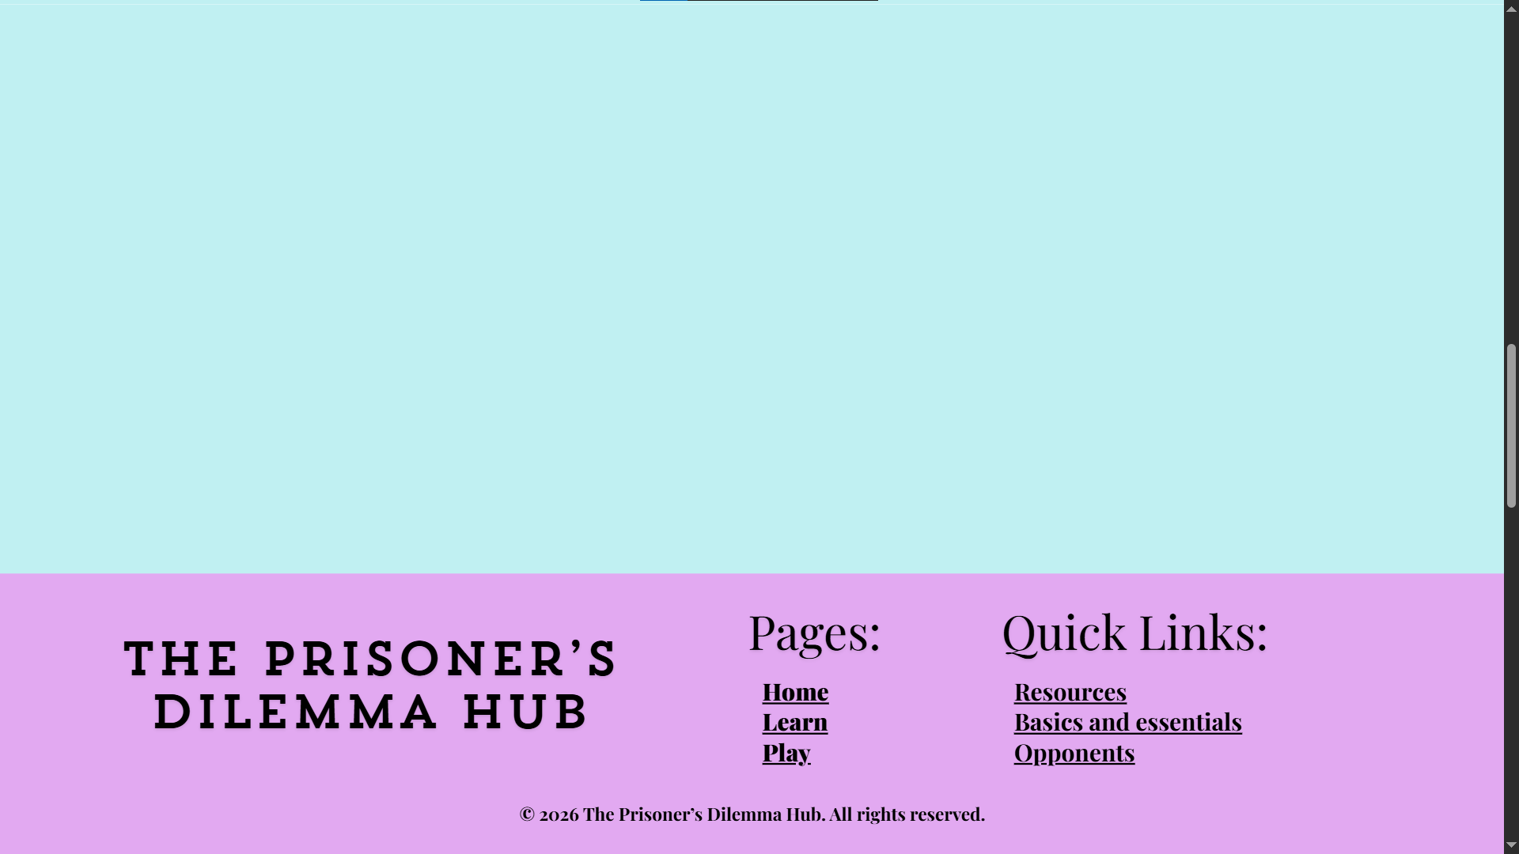
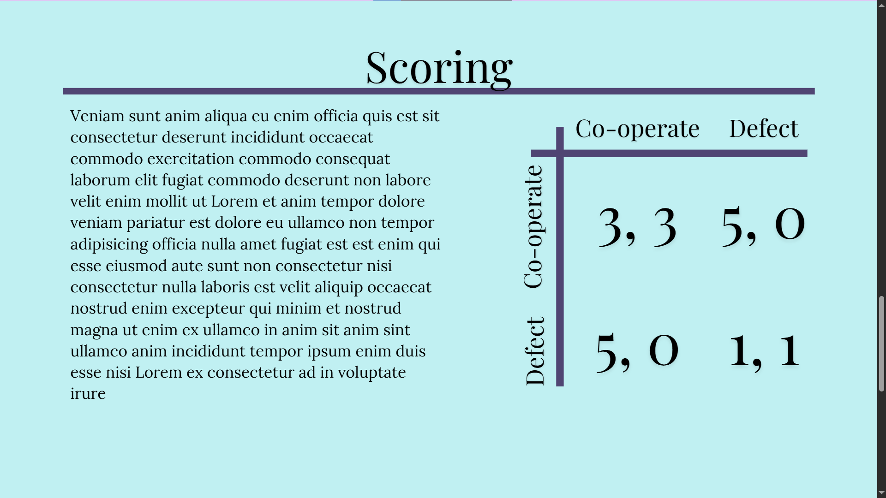
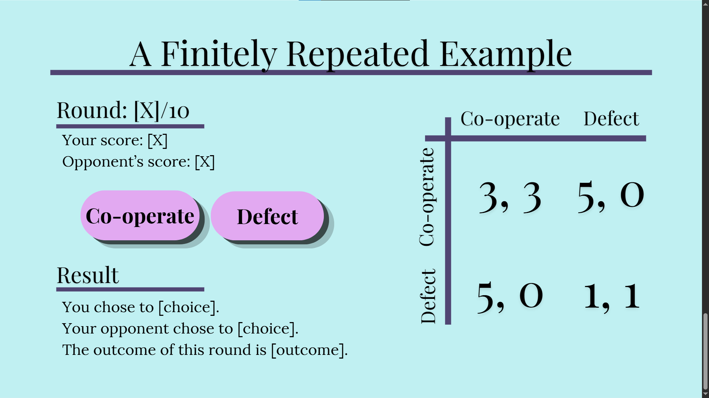
Improved design choices:
Please include intended font choice, color scheme, images and any other relevant information linked to your design based on your Feedback
Changes:
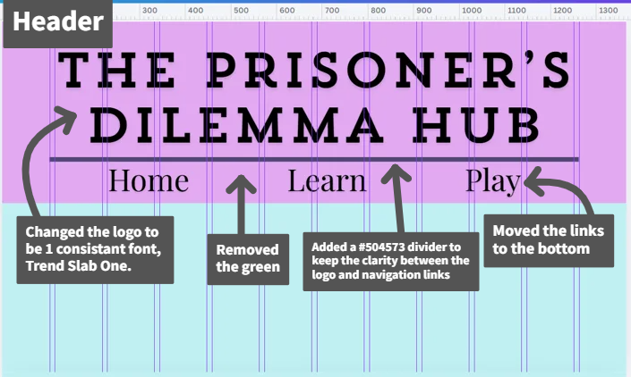
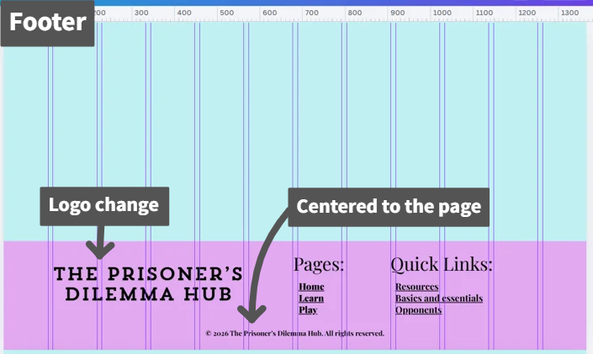
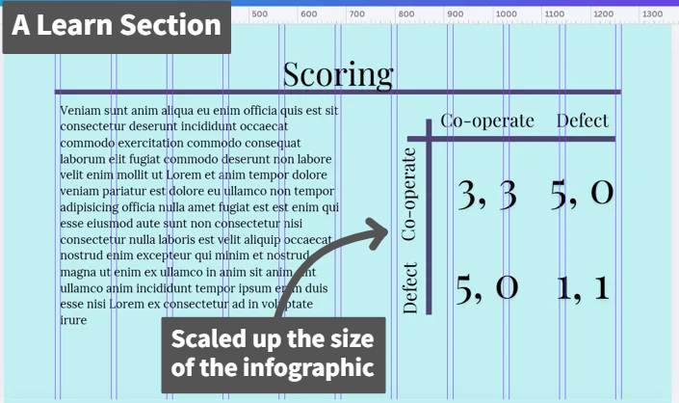
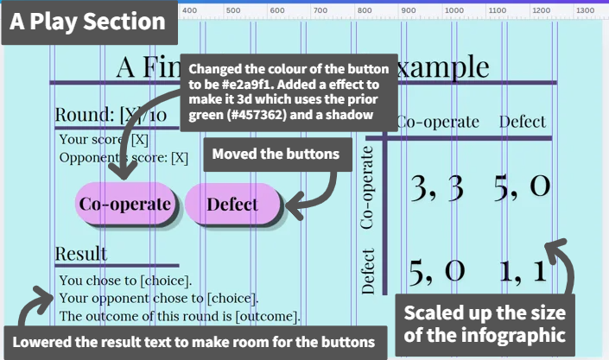

Colours:

Passes adobe colour blindness simulator:

Improved Design 3 – may not be needed?
Brief description of your design: Wireframes of a header, footer, example info section and a simple prisoner’s dilemma game interface. Uses 3 purples, a grey, a light blue, pure black and pure white and follows a 12-column grid pattern.
Screenshot of mockup:
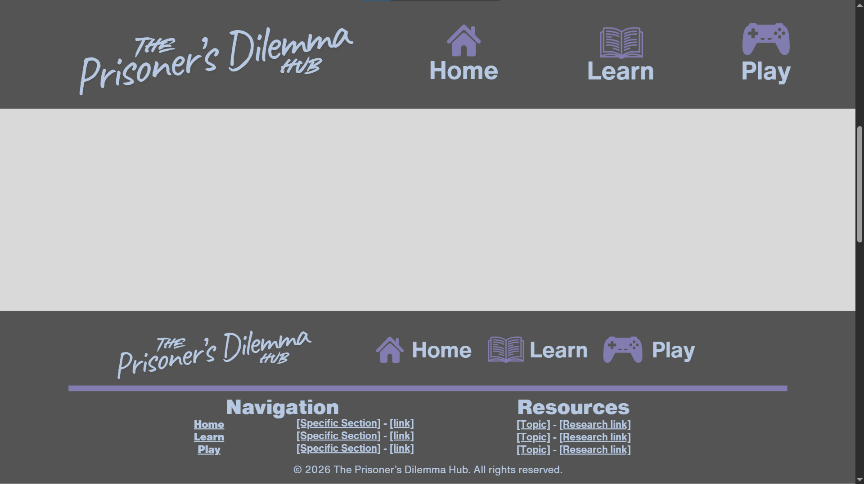
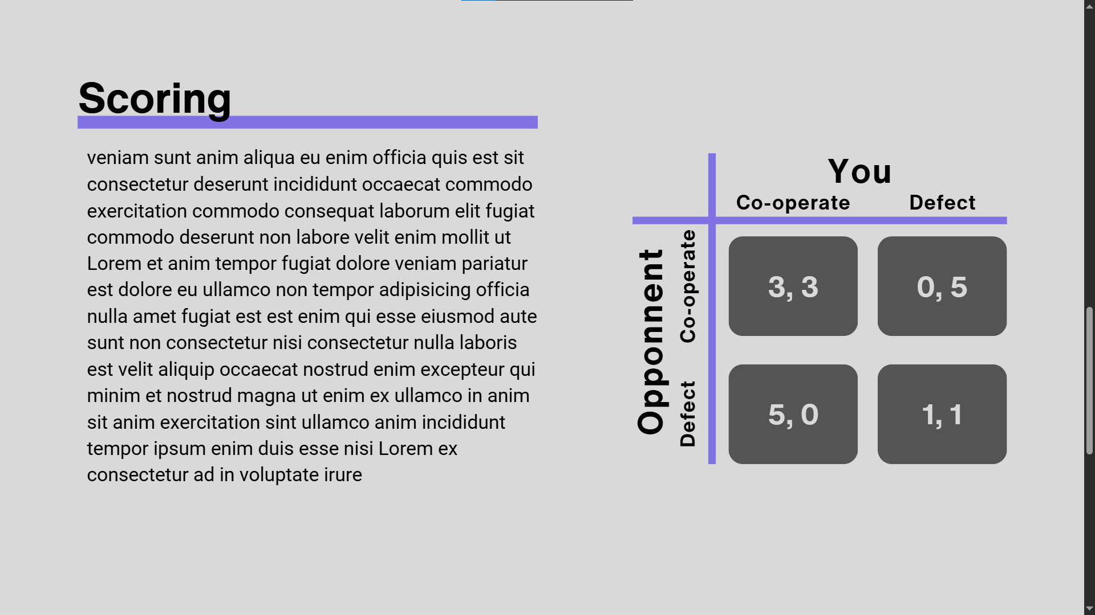
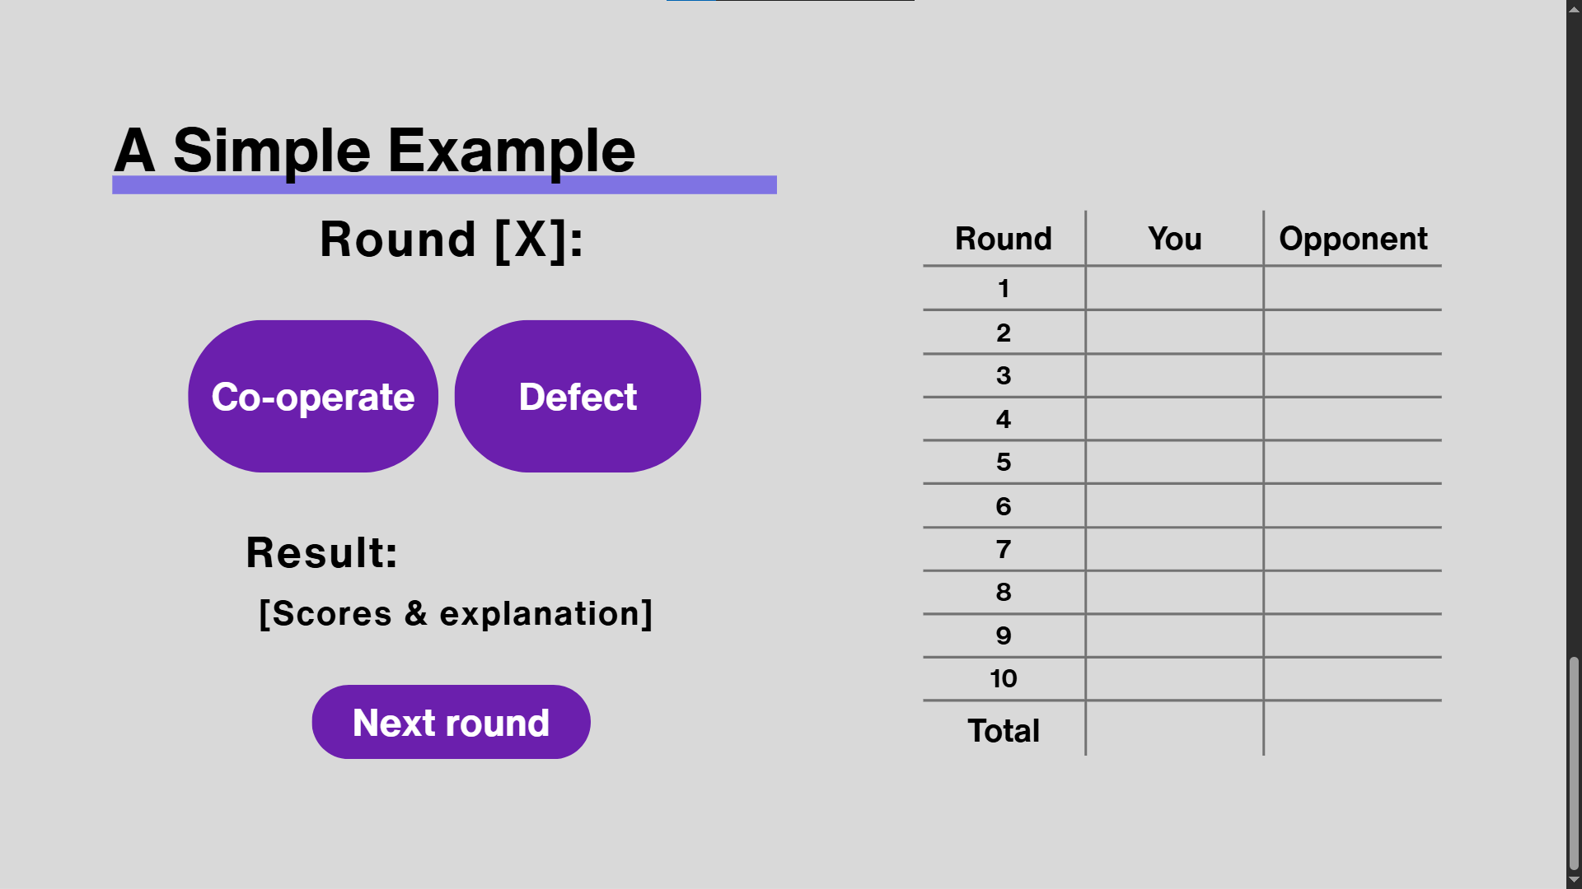
Improved design choices:
Please include intended font choice, color scheme, images and any other relevant information linked to your design based on your Feedback
Changes:
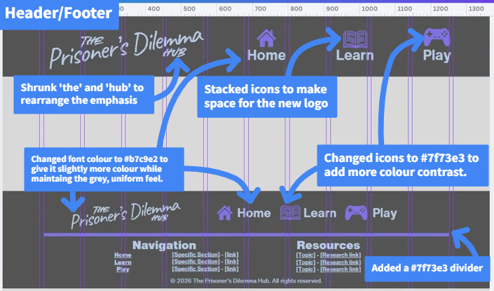
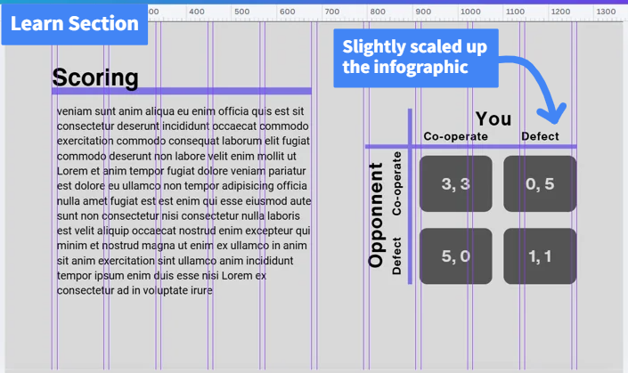
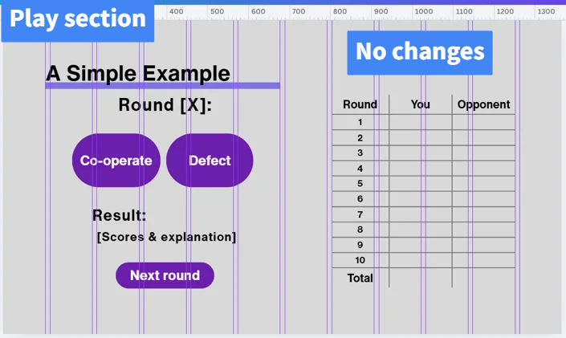

Colours pass adobe colour blindness simulator:
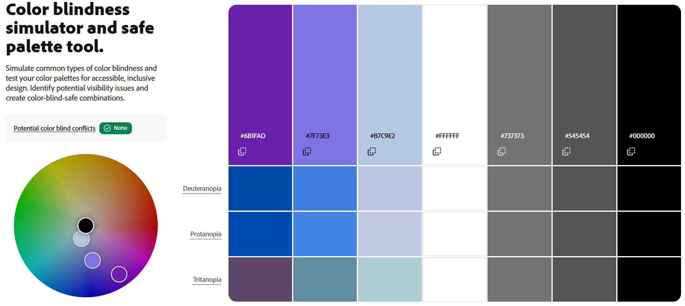
CHECKPOINT FIVE Upload to the Dropbox

EVIDENCE ROUND 2 (You may have only one design at this point to continue with based on feedback from your second round of modelling)
Feedback: Link to feedback if collated in a Google product or other online platform
https://docs.google.com/forms/d/1ibAYwYAXfH-a57yCbqgncqN5_W8Pxfkq0S1cAshdED4/edit
Name of document feedback is recorded in is:
https://docs.google.com/spreadsheets/d/1_D31QU_h5kqeyt5-0Ll7EXDKuuf3rV8vqB7HNeskAmA/edit?usp=sharing
FEEDBACK SUMMARY
Design | Likes/Keep | Dislikes/Change | Summary
Design 1
Design 2 | Colours:  - Contrast between pink and blue  - Overall theme  Fonts:  - Overall font choices  Positioning:  - Spacing and overall | Fonts:  - Down scale logo to make it less squished  - Possibly make headers bold to further differentiate them from text  Positioning:  - Add more padding to text in the infographic  Other:  - Buttons feel out of place in this design | The least liked design. The colours used were liked overall but with mixed opinions with 1 response suggesting that the vibrant colours might be too distracting when a user is genuinely trying to study. The font choices were liked but there were some changes to do with scaling and positioning to make the text itself easier to read/less squashed. There were mixed opinions of the buttons, overall, however, everyone liked them but 1 response pointed out that it didn’t feel like they completely fitted in with the rest of the design, which I somewhat agree with.
Design 3 | Colours:  - Subtleness of colours  Positioning:  - Spacing and overall  - Footer having navigation  Other:  - Overall header and footer | Colours:  - Bright purple buttons  Fonts:  - Too boring  - Inconsistent logo – the change in emphasis did not fix the issue  Positioning:  - Make the next round button slightly larger  - Organise the play section buttons and negative space around the headers | The favourite design despite scoring lower in the question “how well does the colours and font choices fit the purpose of the design”. There were also mixed opinions of the colours, mostly positive with the subtleness of the colours but one negative stating they’d like more colour. The fonts were what I believe the reason for the lower score on the how well does it fit the purpose question. One user voting low because of the inconsistent logo, not liking the indirect solution I had tried, and the others would like a little more variation/interesting font. The header and footer layout was the favourite part of this design.

Improved Design 1
Brief description of your design:
Screenshot of mockup:
Improved design choices:
Please include intended font choice, color scheme, images and any other relevant information linked to your design based on your Feedback

Improved Design 2
Brief description of your design:
Screenshot of mockup:
Improved design choices:
Please include intended font choice, color scheme, images and any other relevant information linked to your design based on your Feedback

Improved Design 3
Brief description of your design: Wireframes of a header, footer, example info section and a simple prisoner’s dilemma game interface. Uses 1 purples, a grey, 2 light blues, pure black and follows a 12-column grid pattern.
Screenshot of mockup:
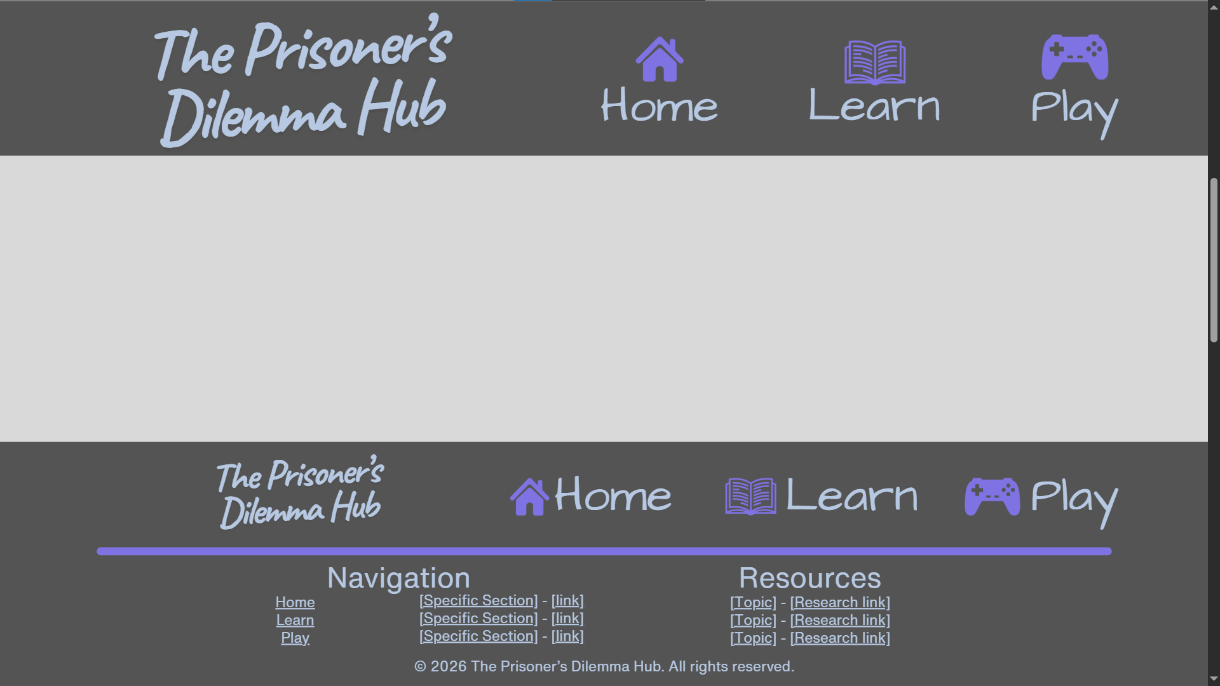
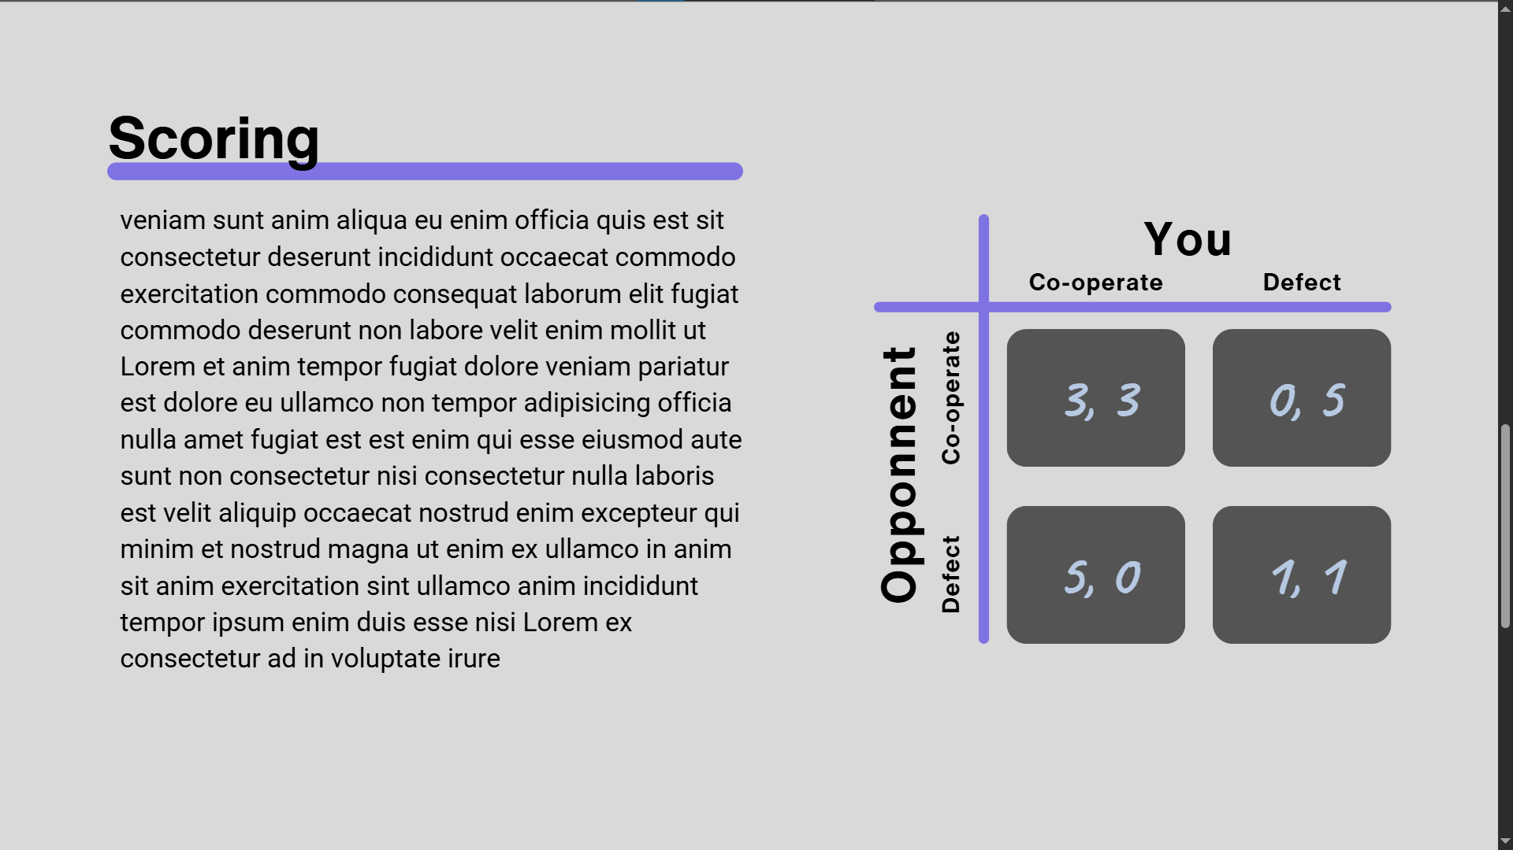
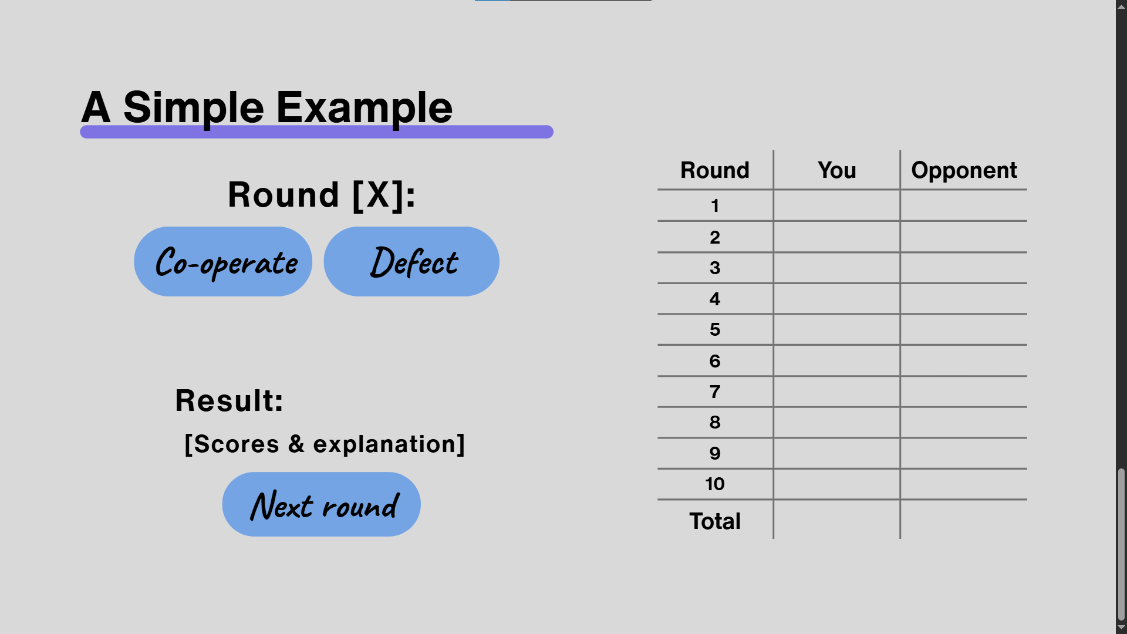
Improved design choices:
Please include intended font choice, color scheme, images and any other relevant information linked to your design based on your Feedback
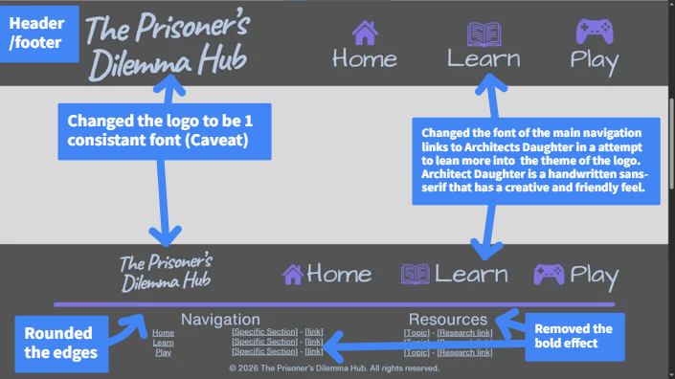
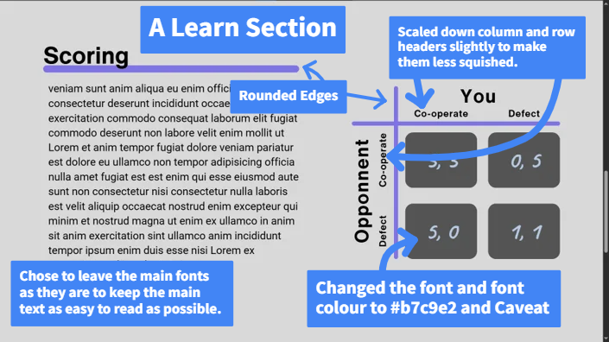
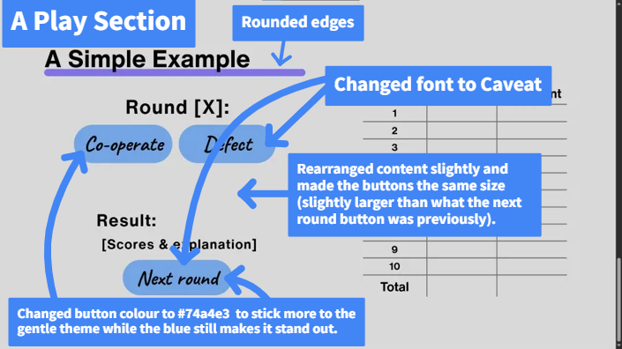

Colours pass adobe colour blindness simulator:
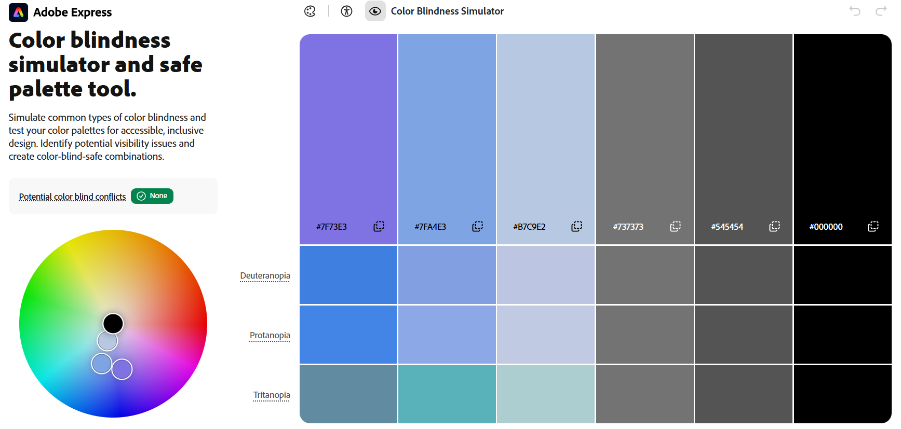
CHECKPOINT SIX Upload to the Dropbox

EVIDENCE ROUND 3 (May or may not be needed based on how you have narrowed your design down.)
Feedback: Link to feedback if collated in a Google product or other online platform
Name of document feedback is recorded in is:
FEEDBACK SUMMARY
Design | Likes/Keep | Dislikes/Change | Summary
Design 1
Design 2
Design 3

Improved Design 1
Brief description of your design:
Screenshot of mockup:
Improved design choices:
Please include intended font choice, color scheme, images and any other relevant information linked to your design based on your Feedback

Improved Design 2 (optional based on design decisions from earlier feedback while modelling)
Brief description of your design:
Screenshot of mockup:
Improved design choices:
Please include intended font choice, color scheme, images and any other relevant information linked to your design based on your Feedback

Improved Design 3 (optional based on design decisions from earlier feedback while modelling)
Brief description of your design:
Screenshot of mockup:
Improved design choices:
Please include intended font choice, color scheme, images and any other relevant information linked to your design based on your Feedback

CHECKPOINT SEVEN Upload to the Dropbox

EVIDENCE: FINAL DESIGN
Feedback: Link to feedback if collated in a Google product or other online platform
https://docs.google.com/forms/d/1llaew7wGZkKxyIrQ6nsVc3oZRX0jNHGqaDfzeoMkhLM/edit#responses
Name of document feedback is recorded in is:
https://docs.google.com/spreadsheets/d/1kIcjM-_hC862HK3h63IWSYL3AYBhOBz-RRAEdy3NnWk/edit?usp=sharing
FEEDBACK SUMMARY FOR FINAL DESIGN
Summarise in terms of purpose, end users, conventions and relevant implications
Final Design
Purpose | Rated an average of 7.75/10 by 4 students, aged 16-21, male and female, in the above form. Overall, they largely agree that the design is fit for its purpose. Everyone liked the fonts and, although there were some slightly differentiating opinions on the colours, the feedback was overall positive. Some testers pointed out the font in the footer being hard to read but because that was mainly just due to the screenshot that had lowered the quality of the image, I decided it wasn’t an actual issue with the design’s fitness of purpose.  With the above feedback I have decided my design fulfils its purpose and no further changes are needed.
End Users | Also rated an average of 7.75/10 by 4 student, aged 16-21, male and female, in the above form. Aside from 1 user who said they didn’t particularly like the colours used everyone else liked the design and thought it would also be liked for others around their age. Even the user who said websites aren’t their “thing” and would rather watch videos said they liked the design, and the one user who said they didn’t love the colours also said that they would be able to use the design regardless without much of a fuss. It seemed that they all agreed that the “font and layout of the pages also do a great job of capturing the attention of the end-users” (quote from one response).  With the above feedback I have decided my design is suitable for the end users and no further changes are needed.
Conventions | Rated an average of 8.75 by 4 students, aged 16-21, male and female in the above form. Everyone highly rated the implementation of the conventions I outlined, unanimously agreeing that the navigation and content hierarchy were good. One response pointed out something to do with the grid structure that I want to implement in the actual outcome, which is the main side of the content alternating sides between sections, which would just mean switching the text and images from side to side, section to section. Overall, the feedback on the colours was positive.  With the above feedback I have decided my design follows the relevant conventions and no further changes are needed.
Relevant  Implications | Also rated an average of 8.75 by 4 students, aged 16-21, male and female in the above form. The responses agreed that the design was uniform, consistent and intuitive. The 1 10/10 response roughly saying that with the correct implementation the design could perfectly fulfil its relevant implications. One user once again brought up the text in the footer but for the same reason as stated in purpose, I don’t think this actually effects the relevant implications.  With the above feedback I have decided my design follows the relevant implications and no further changes are needed.
Section 5: Decision
Refer to Lesson 6 of Module DTO2202

Once you have consulted with end users and got their feedback, you will have a good idea of the design that is suitable to develop into a completed outcome (DTO2204)

 | Assessment Criteria
Achievement/Paetae  Select a chosen design.  Explain the appropriateness of that chosen design in terms of its purpose, end users and relevant implications | Merit/Kaiaka,  Explain how the chosen design uses appropriate conventions. | Excellence/Kairangi  Justify, with evidence, that the chosen design addresses your implications, end-user considerations and uses appropriate conventions

My Final Design:
Place a screenshot of your final design here:
Revisit Section 2 and Section 3 to complete the explaining and justifying
(Text that is coloured purple in this document)

You can continue to complete multiple rounds of design development and feedback to improve your intended design. If you feel there are more improvements to be made or if you haven't gathered enough feedback you are encouraged to submit another improved design for feedback.

You need to make sure that you have gathered enough information to support your design choice in relation to your purpose, end user and relevant implications

Please now have a look at the Assessment Task and make sure you have completed all the work required for the Task in this workbook.

If you have any questions please contact your Digital Technology Teacher

